Expression of CXCL9 orchestrates cytotoxic and regulatory T cell infiltration in renal cell carcinoma

Supplementary Material

Uro study team

2022-10-18

# Supplementary Methods

## Data import and transformation

Clinical information and normalized RNA-seq expression estimates for the Kidney Clear Cell Carcinoma (KIRC) TCGA project (1) were downloaded from the GDC Data Portal with the help of the TCGA-Assembler script (<https://github.com/compgenome365/TCGA-Assembler-2/blob/master/TCGA-Assembler/>). Clinical information and normalized RNA-seq expression data for the CheckMate 010 (CM 010) and CheckMate 025 (CM 025) cohorts were extracted from the report of Braun et al. (2) (Tables S1 and S4 accompanying the paper). To get more insight at possible effects of therapy with immune checkpoint inhibitors, the CheckMate 025 everolimus (CM 025 EVER) and nivolumab (CM 025 NIVO) treatment arms were analyzed separately in the current report. Clinical information and normalized RNA-seq data for the RECA-EU study were extracted from the ICGC Data Portal (3).

Normalized microarray expression data and clinical information for the GSE73731 (4) and GSE167093 (5) cohorts (platforms: Affymetrix Human Genome U133 Plus 2.0 and Illumina HumanHT-12 V4.0 expression beadchip, respectively) were extracted from the GEO API with the *GEOquery* package (6). Normalized microarray expression data (Agilent Human Gene Expression 4x44K v2 Microarray) and clinical information for the E-MTAB 1980 (7) cohort were downloaded from the ArrayExpress portal. For the microarray expression studies, integration of multiple probes targeting the same gene was accomplished by geometric mean. Expression values were treated with the $log_{2}\left(transcriptcount+1\right)$ (RNA sequencing) of log2 transformation (microarray) to improve normality. The clinical characteristic of the analyzed studies is provided in **Table 1**.

Immune infiltration estimates were calculated using the QuanTIseq algorithm (8) implemented in R by the *immunedeconv* package (9).

The following genes were investigated in the current report: *CXCL9* (Entrez ID: 4283), *CXCL10* (3627), *CXCL11* (6373) and *CXCR3* (2833).

## Software

The statistical and bioinformatic analysis was done with R 4.2.0 with the *tidyverse* data science environment (10). Visualization of the analysis results was accomplished with *ggplot2* (11), *cowplot* (12), *ExDA* (<https://github.com/PiotrTymoszuk/ExDA>, violin plots) and *microViz* packages (Forest plots, bar plots of regulation estimates and p values; <https://github.com/PiotrTymoszuk/microViz>). Kaplan-Meier plots were generated with *survminer* (13). Exploratory data analysis was done with the development package *ExDA*.

## Comparison of gene expression between the normal and tumor samples

log2-transformed expression levels of *CXCL9/10/11* and *CCL11* were compared between the matched normal kidney and cancer samples in the TCGA and GSE167093 cohorts with two-tailed paired T test corrected for multiple testing with Benjamini-Hochberg method (14) and Cohen’s d effect size statistic (packages *ExDA* and *rstatix*) (15).

## Hypothesis testing

log2-transformed expression levels of *CXCL9* were compared between tumor grades, tumor stages, between individuals with and without distant metastases at diagnosis, between the MSKCC (Memorial Sloan Kettering Cancer Center) risk groups, between patients with or without overall response to everolimus or nivolumab treatment (response: complete response [CR] or partial response [PR], no response: stable disease [SD] or progressive disease [PD]) were compared by Mann-Whitney test with r effect size statistic or Kruskal-Wallis test with $η^{2}$ effect size statistic, as appropriate (packages *ExDA* and *rstatix*) (15). P values were corrected for multiple testing with Benjamini-Hochberg method (14).

## Co-expression analysis

Co-expression of *CXCL9*, *CXCL10*, *CXCL11* and *CXCR3* (log2-transformed) in the cancer tissue was investigated by Spearman’s correlation (base r function *cor.test()*). P values were corrected for multiple testing with Benjamini-Hochberg method (14).

## Expression of the genes of interest and non-tumor cell infiltration

Association of the log2-transformed expression levels of *CXCL9* and *CXCR3* with the QuanTIseq estimated content of non-tumor cells in the cancer sample (8,9) was investigated with Spearman’s correlation (base r function *cor.test()* and package *ExDA*) with Benjamini-Hochberg adjustment for multiple testing (14).

## Survival stratification

Cancer samples were stratified into low and high expressors of *CXCL9* with the cutoff corresponding to the largest difference in overall or relapse-free survival investigated by Mentel-Henszel test (packages *survival* and in-house-developed package *kmOptimizer*, <https://github.com/PiotrTymoszuk/kmOptimizer>) (16–18). P values were corrected for multiple testing with Benjamini-Hochberg method (14). Differences in survival between the high and low expressors were visualized in Kaplan-Meier plots (package *survminer*) (13).

## Differential gene expression in the CXCL9 expression strata

Cancer samples of the TCGA, CheckMate 010, CheckMate 025 everolimus, CheckMate 025 nivolumab, E-MTAB 1980 and RECA-EU cohorts with survival information provided were stratified as high and low expressors of *CXCL9* by the optimal cutoffs associated with the largest differences in overall survival. Samples of the GSE73731 and GSE167093 collectives with no survival data available were dichotomized by the median *CXCL9* expression values.

Whole-genome differential genes expression in *CXCL9*high versus *CXCL9*low tumors was investigated by Benjamini-Hochberg-corrected two-tailed T test (14). The differentially regulated genes were defined by the adjusted significance cutoff (pFDR < 0.05) and the 1.5-fold regulation cutoff. The numbers of differentially regulated transcripts numbers are presented in **Supplementary Table S2**. The differentially regulated genes are listed in **Supplementary Table S3** available as a supplementary Excel file.

## GO enrichment analysis, signaling pathway modulation, gene set variation analysis

Biological process (BP) gene ontology (GO) term enrichment analysis with the sets of genes differentially regulated in *CXCL9*high versus *CXCL9*low cancers was done with the *goana()* tool (package *limma*) (19). Enrichment significance p values were corrected for multiple testing with Benjamini-Hochberg method (14). Significantly enriched BP GO terms are listed in **Supplementary Table s4**.

Differential modulation of KEGG-listed pathways in *CXCL9*high versus *CXCL9*low cancers based on the regulation estimates for differentially expressed genes was investigated with SPIA (20). Significantly activated or inhibited pathways were identified by combined significance for gene set enrichment and net pathway regulation (pG) corrected for multiple testing with Benjamini-Hochberg method. The tA metric representing the total pathway perturbation was used as an estimate of magnitude of pathway modulation (14,20). Signaling pathways with predicted significant modulation in the *CXCL9* expression strata are listed in **Supplementary Table S5**.

Pooled estimates of differential gene expression based on fold-regulation values and their errors in particular study cohorts were calculated with the inverse variance method implemented by the package *meta* (21). Regulation of particular components of the KEGG pathways ‘NK cell-mediated cytotoxicity’ (HSA 04650), ‘chemokine signaling’ (HSA 04062) and ‘cytokine-cytokine receptor interaction’ (HSA 04060) in the *CXCL9*high versus *CXCL9*low tumors based on these pooled expression redulation estimates was visualized with the *pathview* package (22).

Signatures linked to CD8+ T cells (search regular expression: (CD8_TCELL*)|(CD8_T_CELL*)|(CD8_T_LYMPHOCYTE*)), cytotoxicity (CYTOTOXIC|CYTOTOXICITY), exhaustion (EXHAUST*) and regulatory T cells ((CD8_TCELL*)|(CD8_T_CELL*)|(CD8_T_LYMPHOCYTE*)) were extracted from the local version of the MSig Database (release 7.5.1, <http://www.gsea-msigdb.org/gsea/downloads.jsp>). Gene set variation analysis (GSVA) scores for the gene signature were calculated with the *GSVA* package (23) and the development package *gseaTools* (<https://github.com/PiotrTymoszuk/gseaTools>). GSVA scores were compared between *CXCL9*high and *CXCL9*low cancers by two-tailed T test with Benjamini-Hochberg correction for multiple testing (14).

## Biochemical reaction modulation in the CXCL9 expression strata

Rules of assignment of genes to biochemical reactions were retrieved from the Recon2 human metabolism model available via the BiGG database (24) and the R package *BiGGR* (25). Estimates of differential expression between the *CXCL9*high and *CXCL9*low tumors for all available genes in each cohort were obtained by two-tailed T test as described above. Estimates of biochemical reaction fold-regulation were computed by evaluation of the gene assignment rules following the ‘gene - protein - reaction’ (GPR) principle. The ‘geneA OR geneB’ operator was interpreted as the arithmetic mean of gene A and gene B estimates of differential expression. The ‘geneA AND geneB’ operator was interpreted as the minimum of gene A and gene B estimates of differential expression (25). Standard deviation, 95% confidence intervals and p values for the predicted reaction regulation estimates were obtained by a Monte Carlo simulation with n = 1000 draws from normal distribution of gene expression regulation estimates (mean: differential expression estimate, standard deviation: standard error of the differential expression estimate) (25). The analysis was done with the package *BiGGR* (25) and the development package *biggrExtra* (<https://github.com/PiotrTymoszuk/biggrExtra>). Biochemical reactions with predicted significant modulation in the *CXCL9* expression strata are listed in **Supplementary Table S6**.

Pooled estimates of differential gene expression based on fold-regulation values and their errors in particular study cohorts were calculated with the inverse variance method implemented by the package *meta* (21). Based on such pooled expression estimates, a pooled metabolic model was constructed as described above with the packages *BiGGR* and *biggrExtra*. This model was used for visualization of selected metabolic pathways (25).

## Data and code availability

Data analyzed within the study are publicly available. The study pipeline is available at … to be filled in ….

# Supplementary Tables

Supplementary Table S1: Descriptive characteristics of tissue donors for flow cytometry analysis.

| **Variable** | **Patient 1** | **Patient 2** | **Patient 3** | **Patient 4** |
| --- | --- | --- | --- | --- |
| Age, years | 61 | 55 | 81 | 77 |
| Sex | male | male | male | male |
| Tumor grade | 2 | 1 | 2 | 1 |
| Tumor stage | T1 | T3 | T1 | T1 |
| Lymph node stage | N0 | N0 | N0 | N0 |
| Previous RCC treatment | no | no | no | no |
| Tumor entity | ccRCC | ccRCC | ccRCC | ccRCC |
| Peripheral leukocytes, cells/nL | 6.38 | 9.24 | 6.34 | 4.24 |

Supplementary Table S2: Numbers of genes differentially regulated in in CXCL9 high versus CXCL9 low tumor samples.

| **Cohort** | **N downregulated** | **N upregulated** |
| --- | --- | --- |
| TCGA | 150 | 1,350 |
| E-MTAB 1980 | 2 | 381 |
| GSE73731 | 15 | 362 |
| GSE167093 | 0 | 60 |
| RECA-EU | 2 | 231 |
| CM 010 | 1 | 12 |
| CM 025 EVER | 6 | 98 |
| CM 025 NIVO | 80 | 503 |

Supplementary Table S3: Genes differentially regulated in CXCL9 high versus CXCL9 low tumor samples. The table is available as a supplementary Excel file.

Supplementary Table S4: Biological process gene ontology (GO) terms significantly enriched in the set of genes differentially regulated in CXCL9 high versus CXCL9 low tumors. The table is available as a supplementary Excel file.

Supplementary Table S5: KEGG (Kyoto Encyclopedia of Genes and Genomes) signaling pathways predicted to be significantly regulated in CXCL9 high versus CXCL9 low tumors by the SPIA tool. The table is available as a supplementary Excel file.

Supplementary Table S6: Metabolic reactions predicted to be significantly modulated in CXCL9 high versus CXCL9 low tumors. The table is available as a supplementary Excel file.

# Supplementary Figures

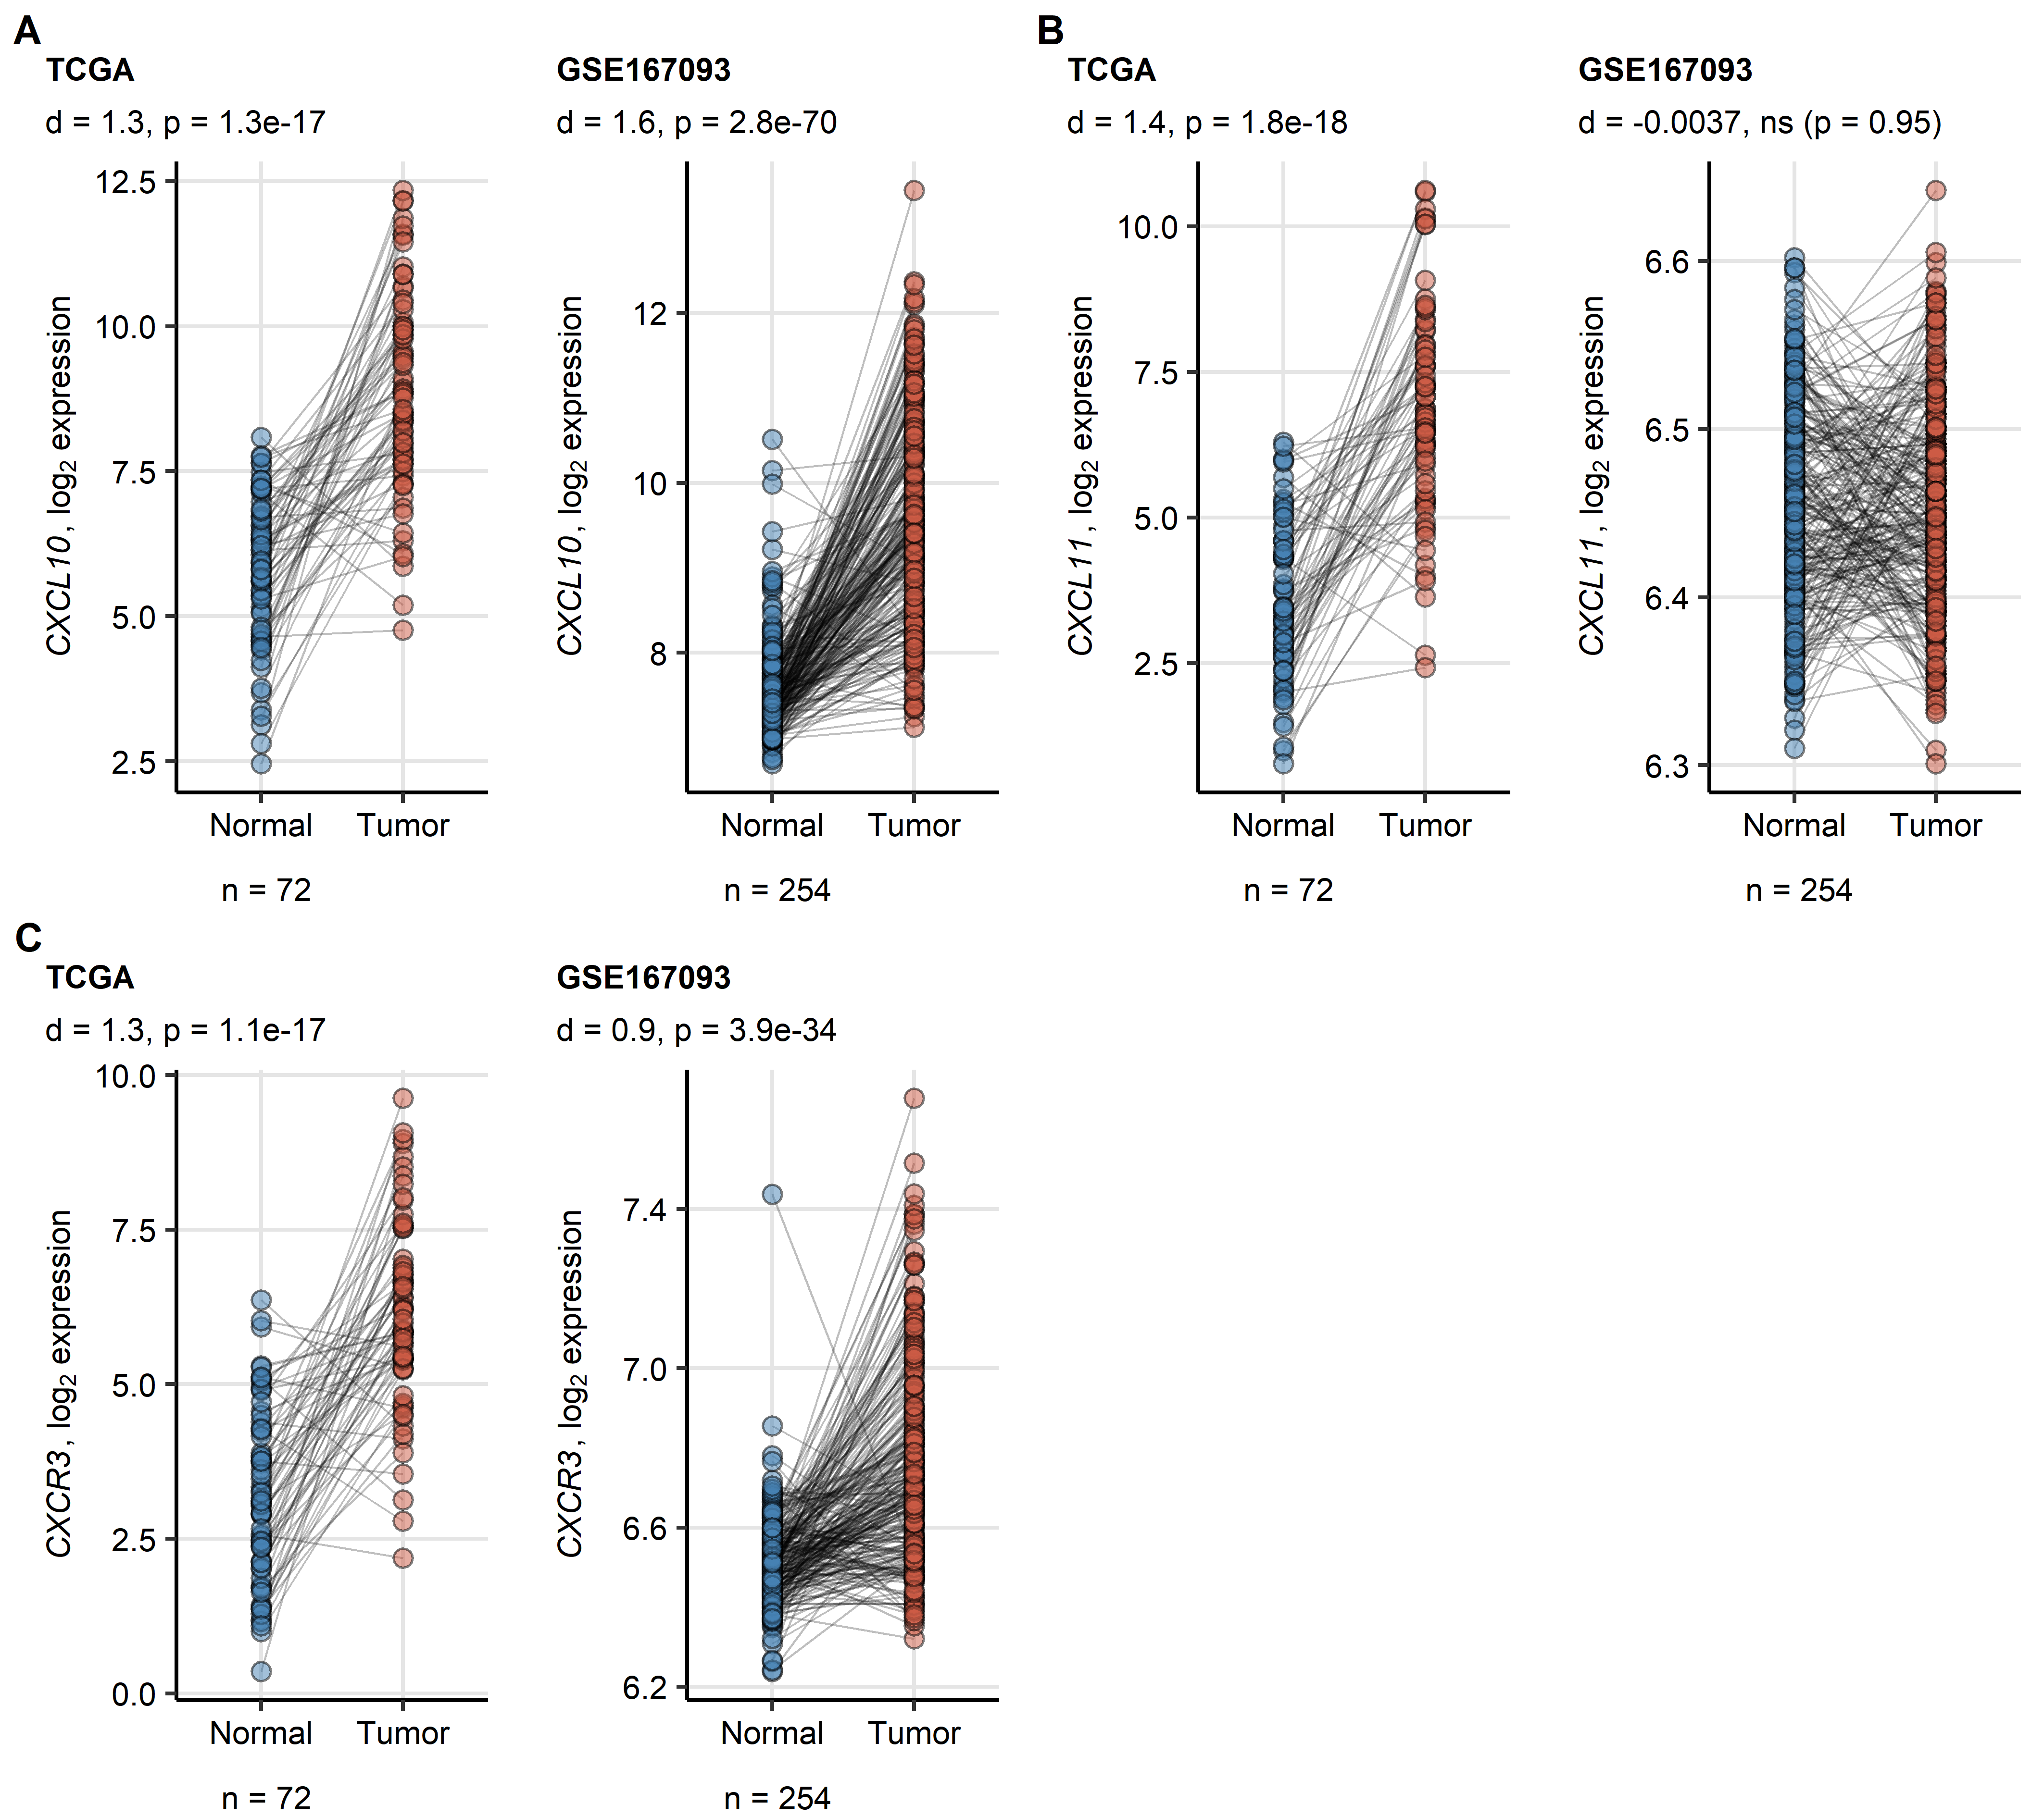

**Supplementary Figure S1. Expression of CXCL10, CXCL11 and CXCR3 in the normal kidney and RCC.** *Differences in log2-transformed expression of CXCL10 (A), CXCL11 (B) and CXCR3 (C) between the matched normal kidney and RCC samples in the TCGA and GSE73731 cohorts were investigated by two-tailed paired T test with Cohen’s d effect size statistic. P values were corrected for multiple testing with Benjamini-Hochberg method. Points represent single samples, samples from the same tissue donors are connected with lines. Effect size statistic and p values are displayed in the plot captions. Numbers of tissue donors are indicated under the plots.*

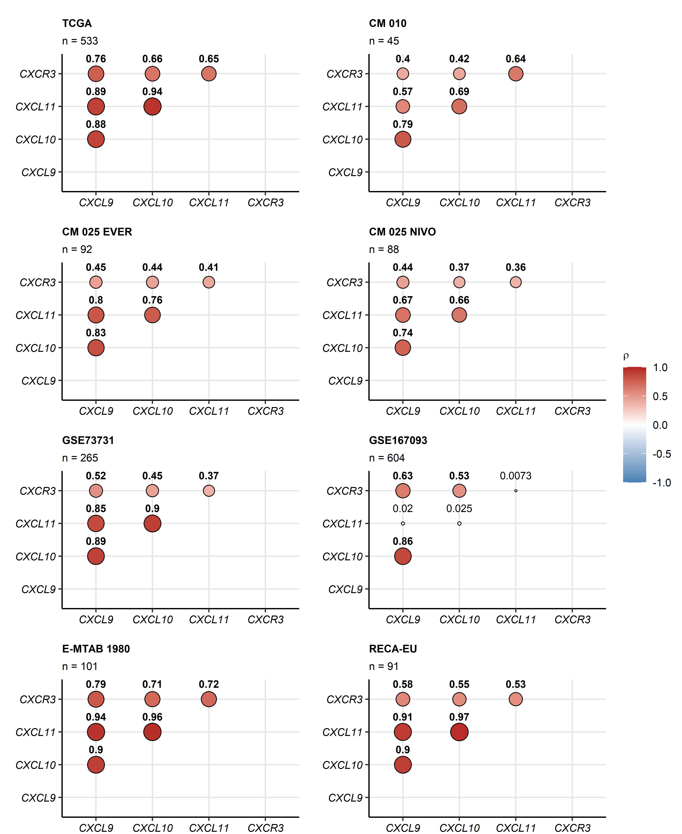

**Supplementary Figure S2. Co-regulation of CXCL9, CXCL10, CXCL11 and CXCR3 expression in RCC.** *Pair-wise correlation of log2-transformed expression levels of CXCL9, CXCL10, CXCL11 and CXCR3 in RCC samples was investigated by Spearman’s test with Benjamini-Hochberg correction for multiple testing. Values of correlation coefficients $ρ$ are presented as bubble plots. Point size represents the absolute value of $ρ$, point size codes for $ρ$ value. Points are labeled with $ρ$ values. Significant correlations are highlighted in bold. Numbers of complete observations are indicated in the plot captions. CM: CheckMate, EVER: everolimus, NIVO: nivolumab.*

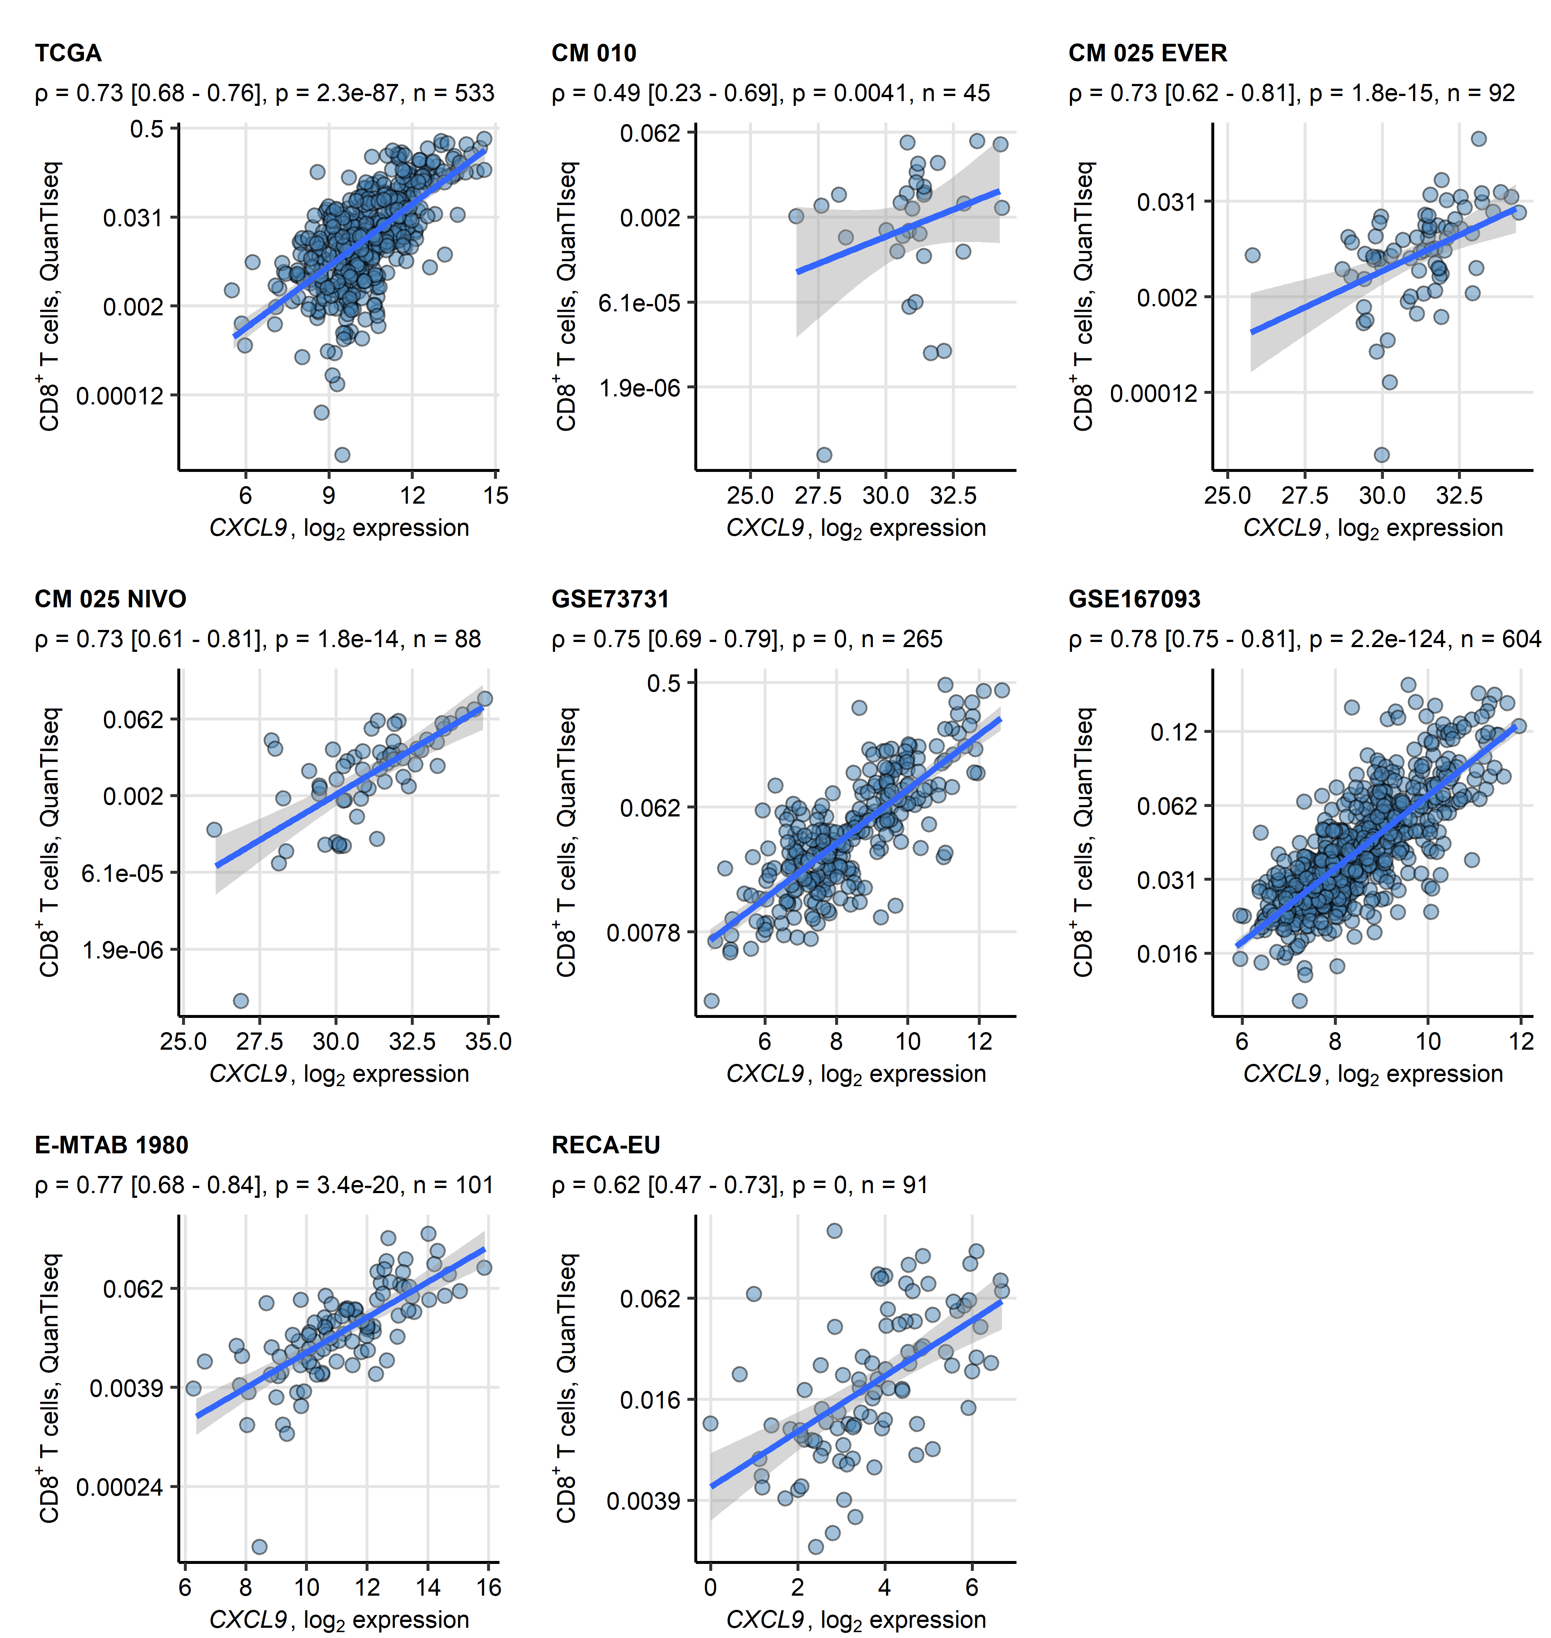

**Supplementary Figure S3. Correlation of CXCL9 expression in tumor tissue with predicted infiltration by CD8+ T cells.** *Levels of CD8+ T cells in cancer samples were predicted with the QuanTIseq algorithm. Correlation of the CD8+ infiltration estimates and log2-transformed levels of CXCL9 expression was investigated by Spearman’s test corrected for multiple testing with Benjamini-Hochberg method. Points represent single cancer samples. Blue lines with gray ribbons represent the fitted linear trends with 95% confidence intervals. Correlation coefficients with 95% confidence intervals, p values and numbers of complete observations are displayed in the plot captions. CM: CheckMate, EVER: everolimus, NIVO: nivolumab.*

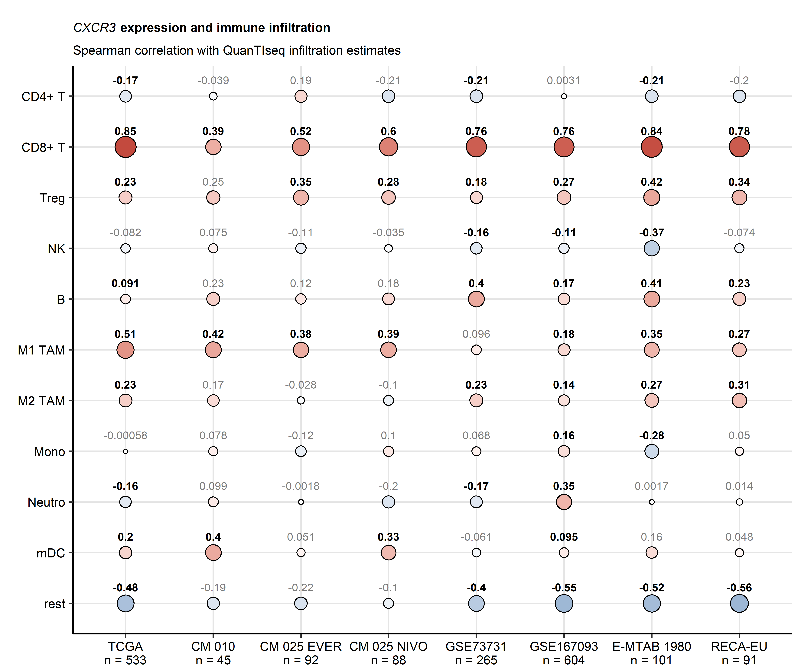

**Supplementary Figure S4. Correlation of CXCR3 expression in RCC with immune cell infiltration.** *Levels of immune cells in cancer samples were predicted with the QuanTIseq algorithm. Correlation of the immune infiltration estimates and log2-transformed levels of CXCR3 expression was investigated by Spearman’s test corrected for multiple testing with Benjamini-Hochberg method. Correlation coefficients $ρ$ are presented in a bubble plot. Point size corresponds to the absolute $ρ$ value, point color corresponds to the $ρ$ value. Points are labeled with the $ρ$ values, significant correlations are highlighted in bold. Numbers of complete observations are indicated in the X axis. CM: CheckMate, EVER: everolimus, NIVO: nivolumab, Treg: regulatory T cells, NK: natural killer cells, TAM: tumor-associated macrophages, Mono: monocytes, Neutro: neutrophils, mDC: myeloid dendritic cells.*

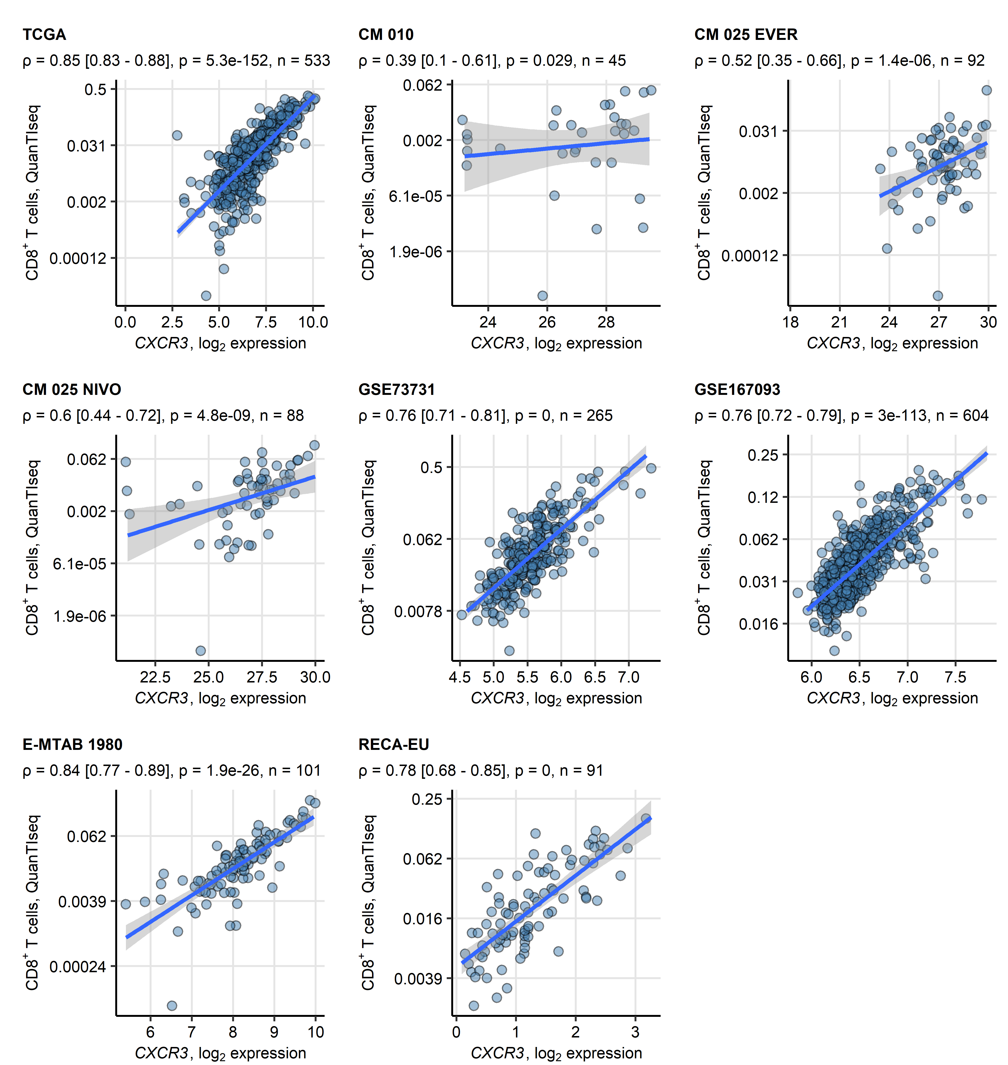

**Supplementary Figure S5. Correlation of CXCR3 expression in tumor tissue with predicted infiltration by CD8+ T cells.** *Levels of CD8+ T cells in cancer samples were predicted with the QuanTIseq algorithm. Correlation of the CD8+ infiltration estimates and log2-transformed levels of CXCR3 expression was investigated by Spearman’s test corrected for multiple testing with Benjamini-Hochberg method. Points represent single cancer samples. Blue lines with gray ribbons represent the fitted linear trends with 95% confidence intervals. Correlation coefficients with 95% confidence intervals, p values and numbers of complete observations are displayed in the plot captions. CM: CheckMate, EVER: everolimus, NIVO: nivolumab.*

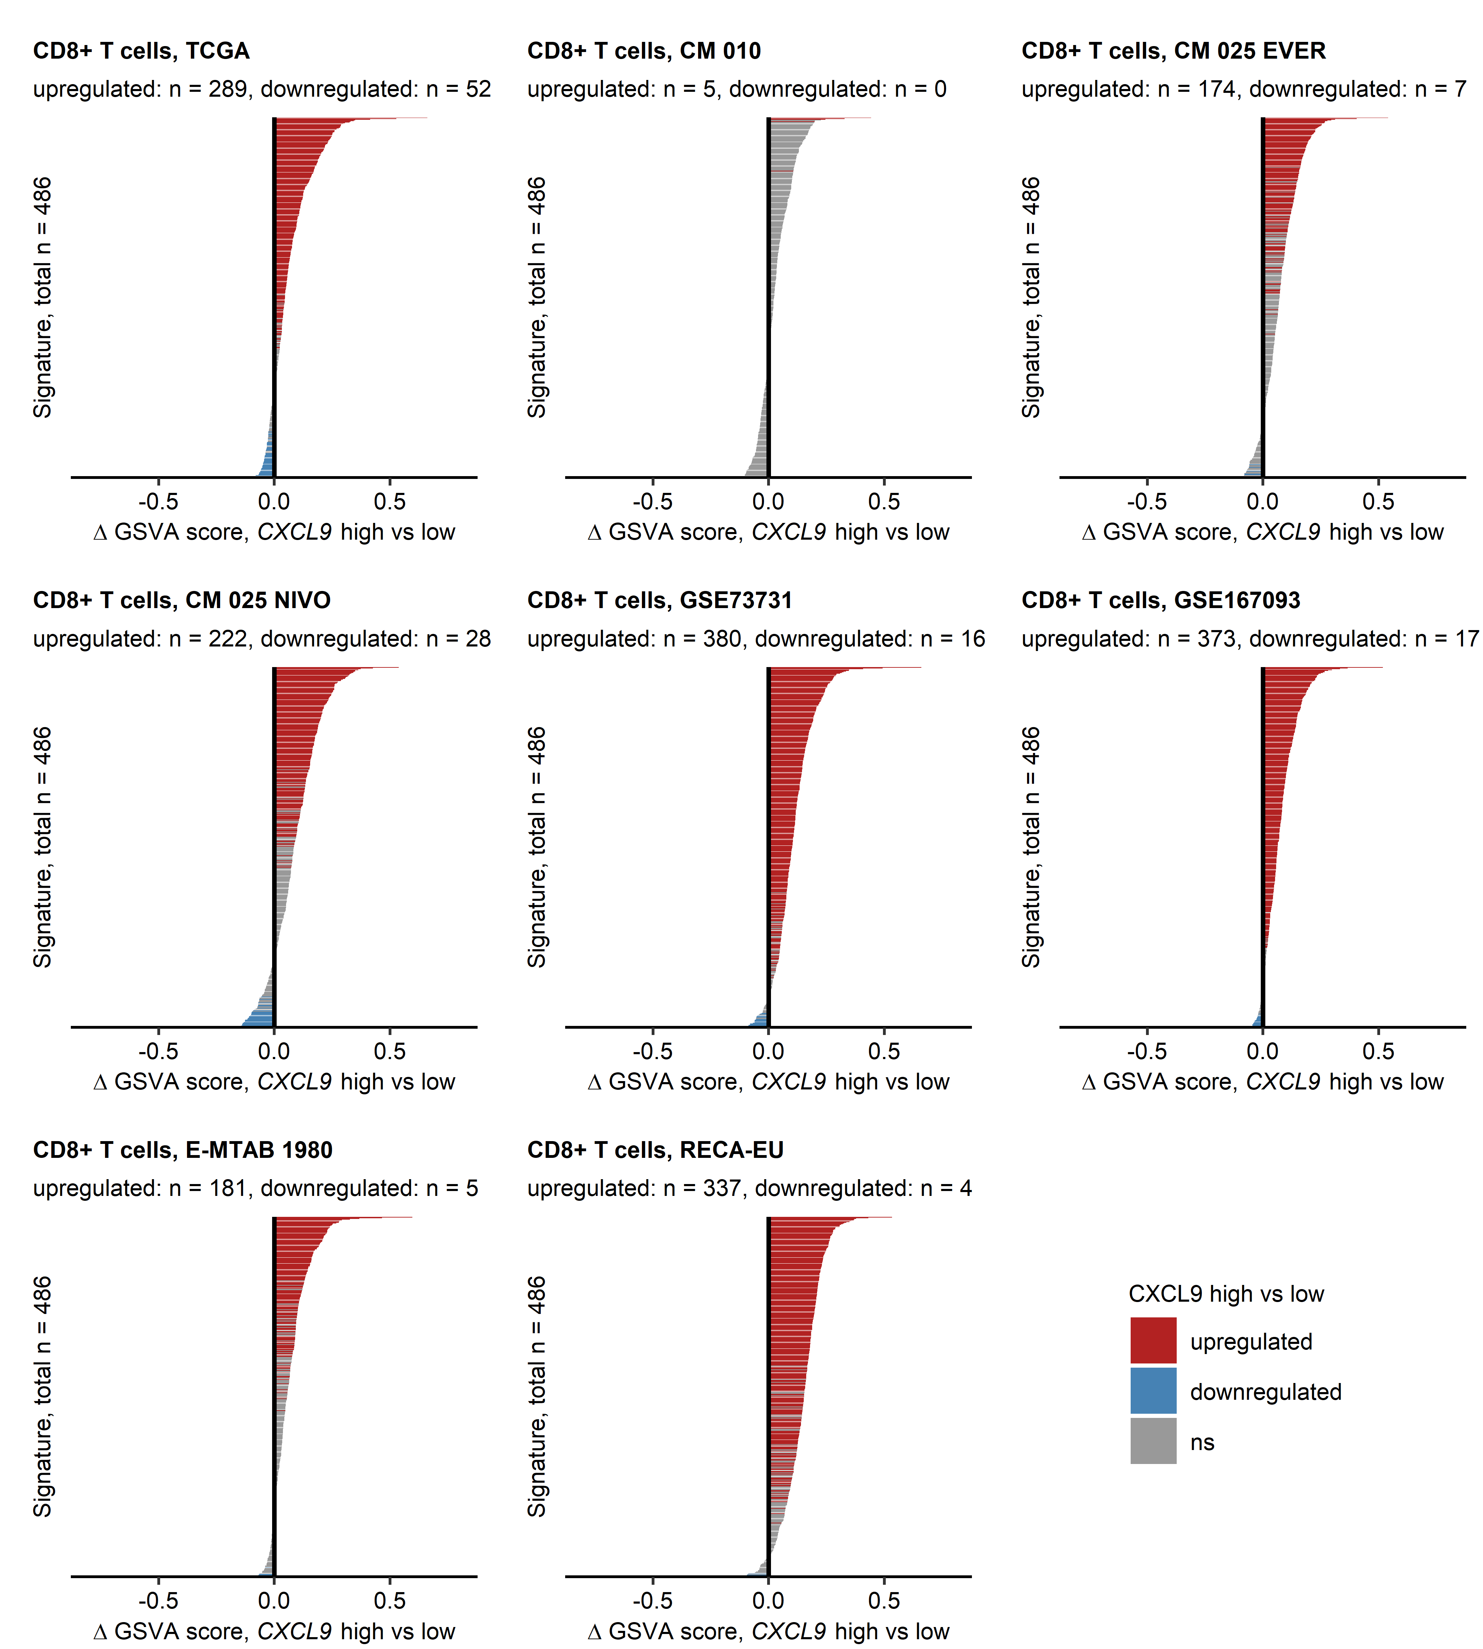

**Supplementary Figure S6. Gene set variation analysis for CD8+ T cell signatures in CXCL9high and CXCL9low RCC.** *Cancers samples were classified as CXCL9high and CXCL9low with the cutoffs corresponding to the largest difference in overall survival (TCGA, CM 010, CM 025, E-MTAB 1980 and EU RECA) or by the median CXCL9 expression (GSE73731, GSE167093). Gene set variation analysis (GSVA) scores for gene signatures linked to CD8+ T cells were compared between the CXCL9 expression strata with two-tailed T test corrected for multiple testing with Benjamini-Hochberg method. Differences in GSVA scores ( GSVA) between the CXCL9high and CXCL9low cancers are presented in bar plots. Bar color codes for regulation sign and significance. Total numbers of analyzed signatures are indicated in the Y axes. Numbers of significantly up- and downregulated GSVA scores are displayed in the plot captions. CM: CheckMate, EVER: everolimus, NIVO: nivolumab.*

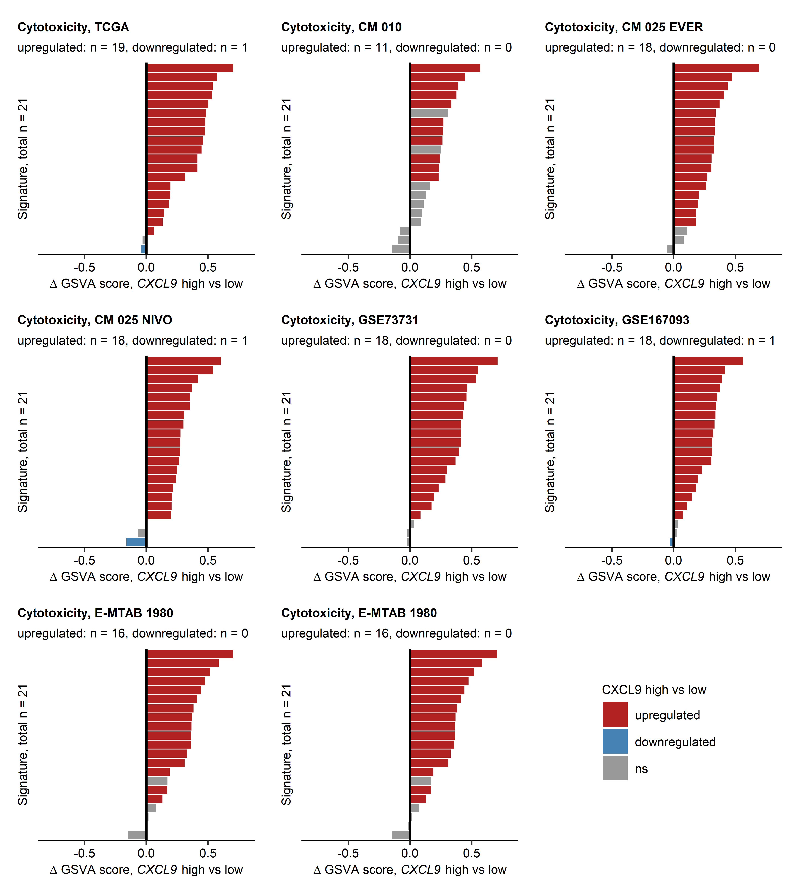

**Supplementary Figure S7. Gene set variation analysis for cytotoxicity signatures in CXCL9high and CXCL9low RCC.** *Cancers samples were classified as CXCL9high and CXCL9low with the cutoffs corresponding to the largest difference in overall survival (TCGA, CM 010, CM 025, E-MTAB 1980 and EU RECA) or by the median CXCL9 expression (GSE73731, GSE167093). Gene set variation analysis (GSVA) scores for gene signatures linked to cytotoxicity were compared between the CXCL9 expression strata with two-tailed T test corrected for multiple testing with Benjamini-Hochberg method. Differences in GSVA scores ( GSVA) between the CXCL9high and CXCL9low cancers are presented in bar plots. Bar color codes for regulation sign and significance. Total numbers of analyzed signatures are indicated in the Y axes. Numbers of significantly up- and downregulated GSVA scores are displayed in the plot captions. CM: CheckMate, EVER: everolimus, NIVO: nivolumab.*

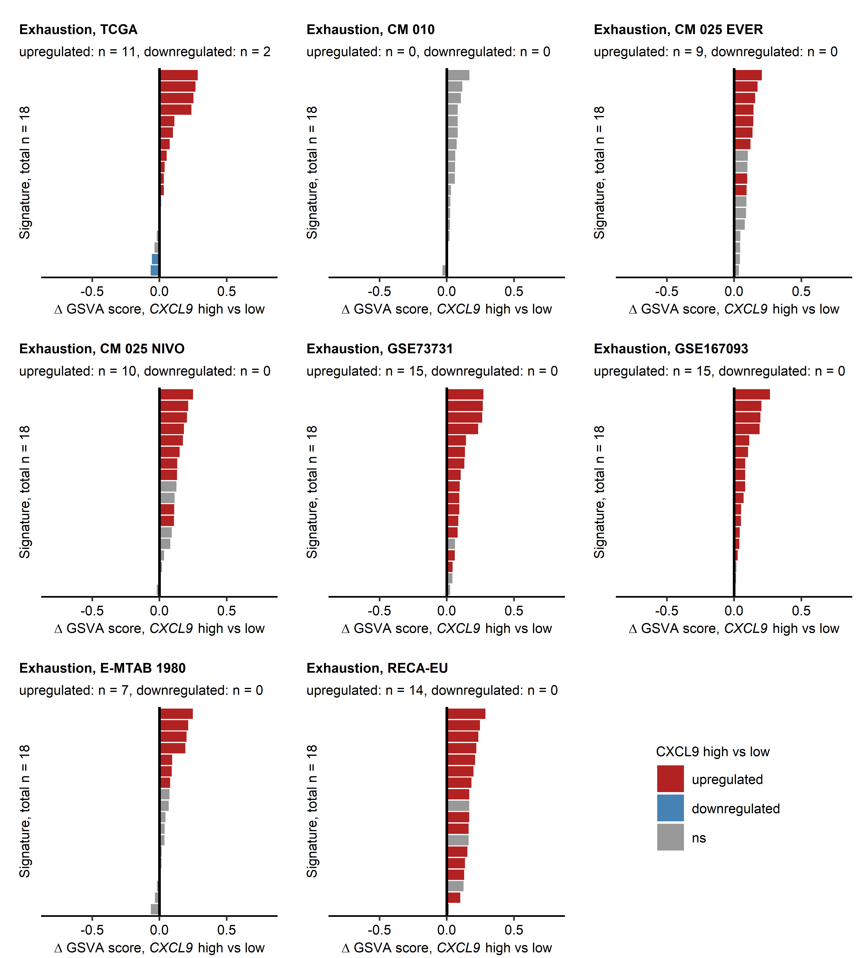

**Supplementary Figure S8. Gene set variation analysis for T cell exhaustion signatures in CXCL9high and CXCL9low RCC.** *Cancers samples were classified as CXCL9high and CXCL9low with the cutoffs corresponding to the largest difference in overall survival (TCGA, CM 010, CM 025, E-MTAB 1980 and EU RECA) or by the median CXCL9 expression (GSE73731, GSE167093). Gene set variation analysis (GSVA) scores for gene signatures linked to T cell exhaustion were compared between the CXCL9 expression strata with two-tailed T test corrected for multiple testing with Benjamini-Hochberg method. Differences in GSVA scores ( GSVA) between the CXCL9high and CXCL9low cancers are presented in bar plots. Bar color codes for regulation sign and significance. Total numbers of analyzed signatures are indicated in the Y axes. Numbers of significantly up- and downregulated GSVA scores are displayed in the plot captions. CM: CheckMate, EVER: everolimus, NIVO: nivolumab.*

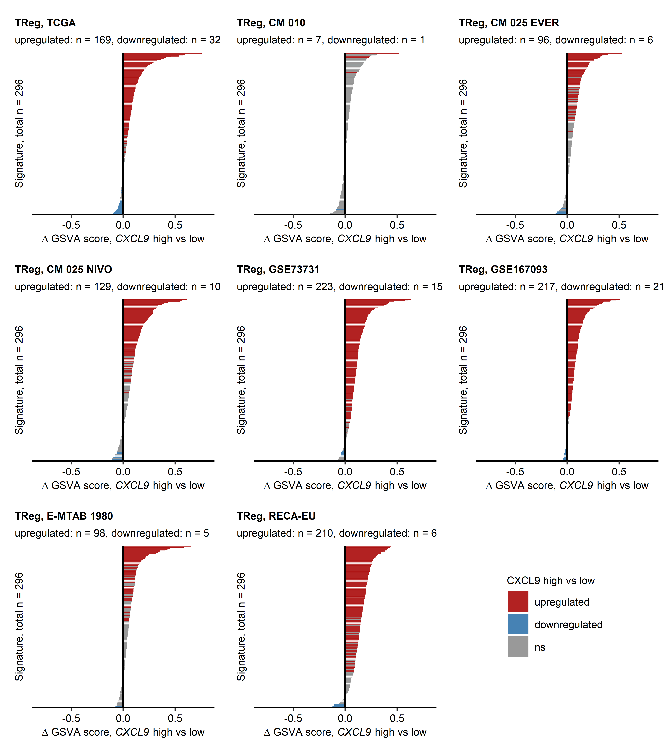

**Supplementary Figure S9. Gene set variation analysis for regulatory T cell signatures in CXCL9high and CXCL9low RCC.** *Cancers samples were classified as CXCL9high and CXCL9low with the cutoffs corresponding to the largest difference in overall survival (TCGA, CM 010, CM 025, E-MTAB 1980 and EU RECA) or by the median CXCL9 expression (GSE73731, GSE167093). Gene set variation analysis (GSVA) scores for gene signatures linked to regulatory T cells were compared between the CXCL9 expression strata with two-tailed T test corrected for multiple testing with Benjamini-Hochberg method. Differences in GSVA scores ( GSVA) between the CXCL9high and CXCL9low cancers are presented in bar plots. Bar color codes for regulation sign and significance. Total numbers of analyzed signatures are indicated in the Y axes. Numbers of significantly up- and downregulated GSVA scores are displayed in the plot captions. CM: CheckMate, EVER: everolimus, NIVO: nivolumab.*

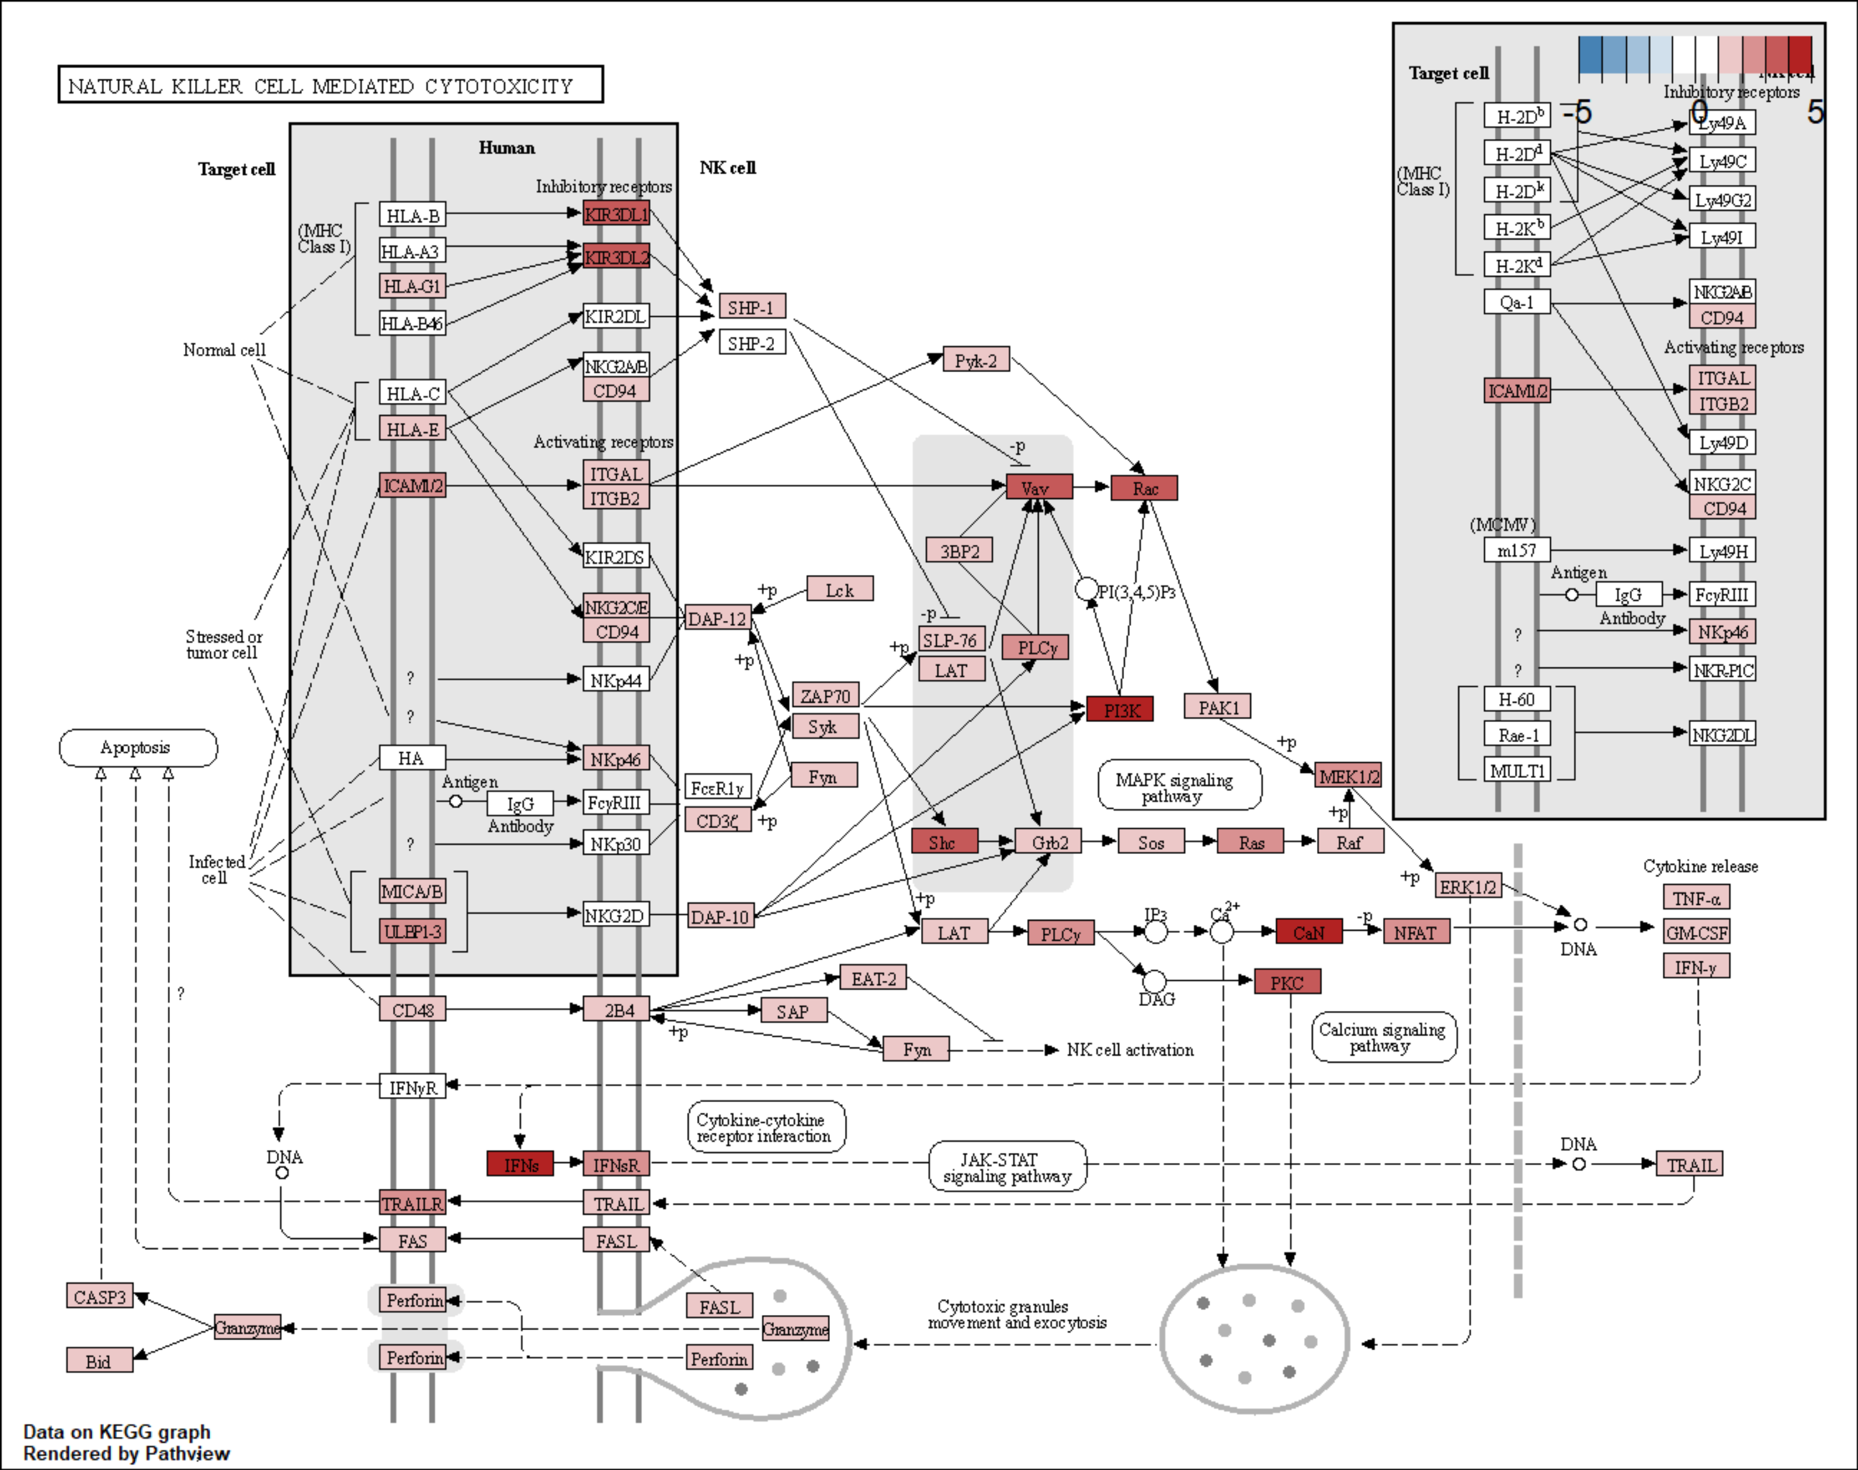

**Supplementary Figure S10. Pathview diagram of modulation of the KEGG NK cell-mediated cytotoxicity pathway for CXCL9high RCC.** *Regulation of particular components of the KEGG pathway NK cell-mediated cytotoxicity (HSA 04650) based on differential gene expression in CXCL9high versus CXCL9low cancers was visualized with the Pathview tool. Color labeling of the pathway components corresponds to the fold-regulation estimate versus CXCL9low tumors.*

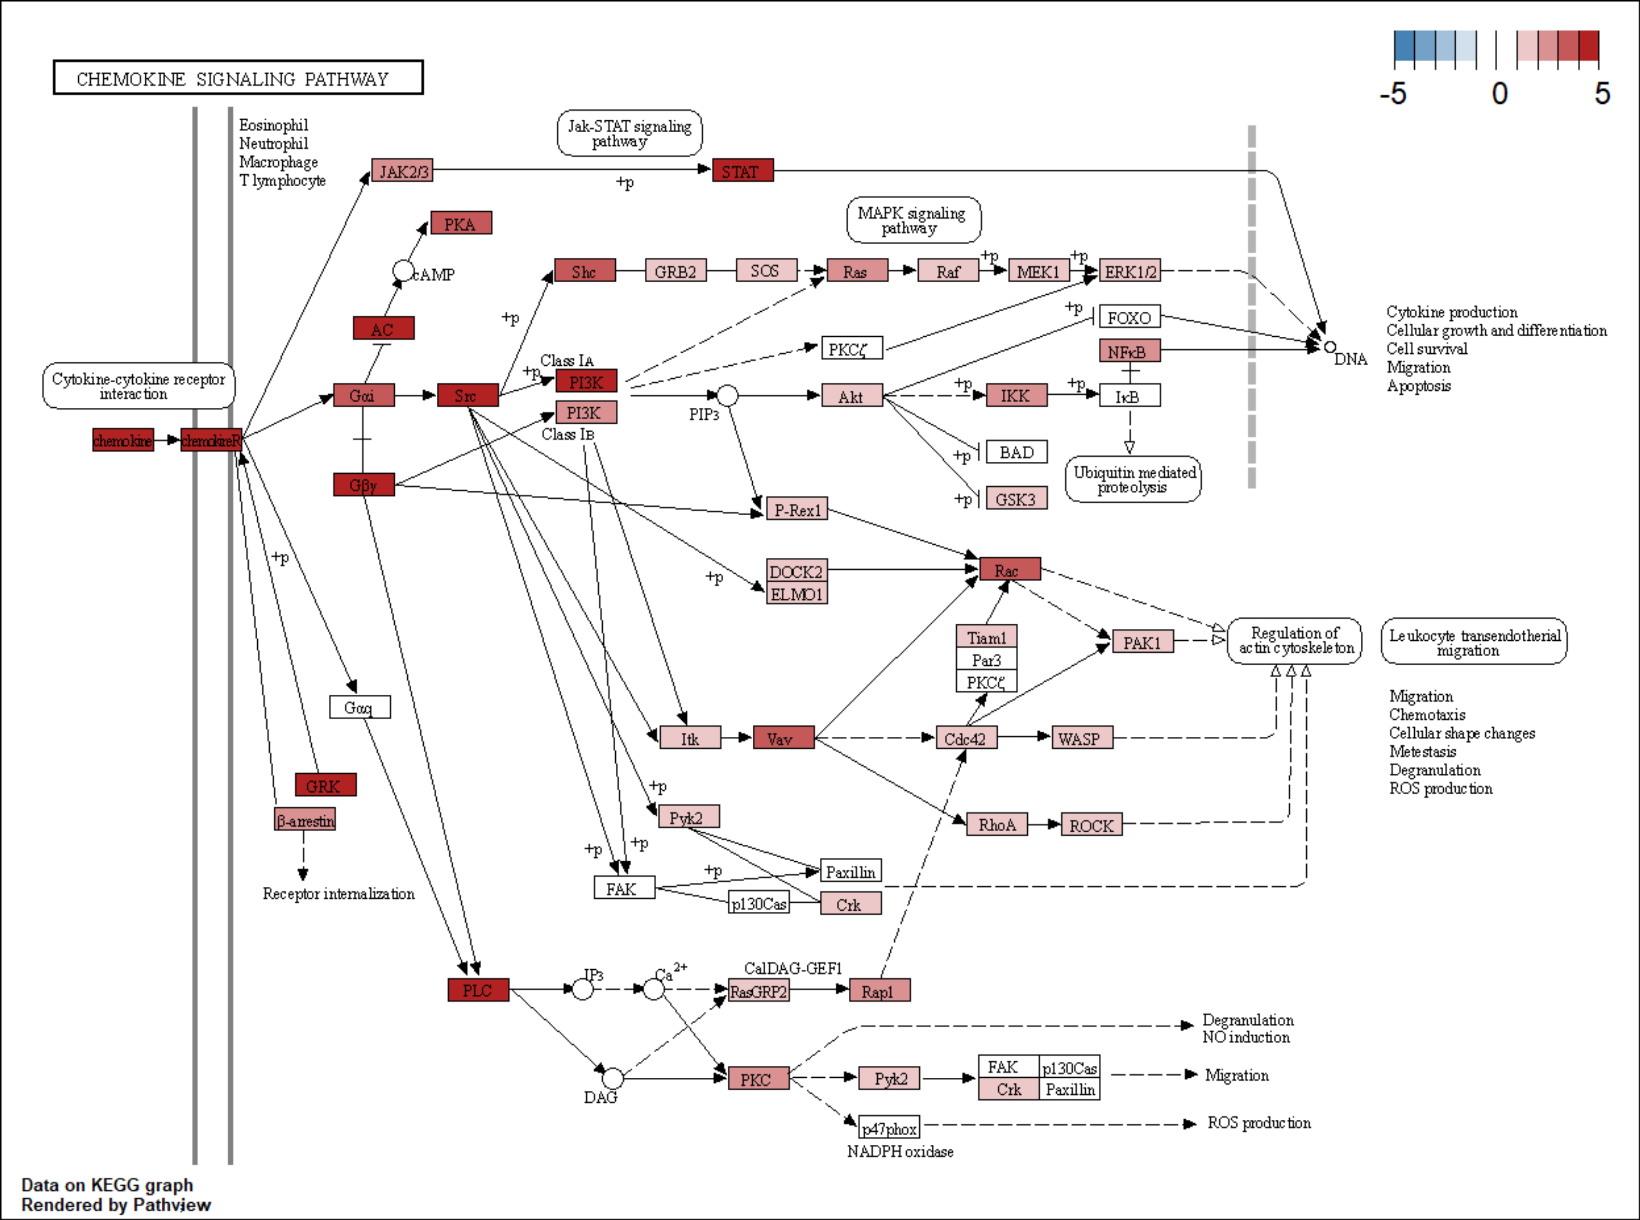

**Supplementary Figure S11. Pathview diagram of modulation of the KEGG chemokine signaling pathway for CXCL9high RCC.** *Regulation of particular components of the KEGG chemokine signaling pathway (HSA 4062) based on differential gene expression in CXCL9high versus CXCL9low cancers was visualized with the Pathview tool. Color labeling of the pathway components corresponds to the fold-regulation estimate versus CXCL9low tumors.*

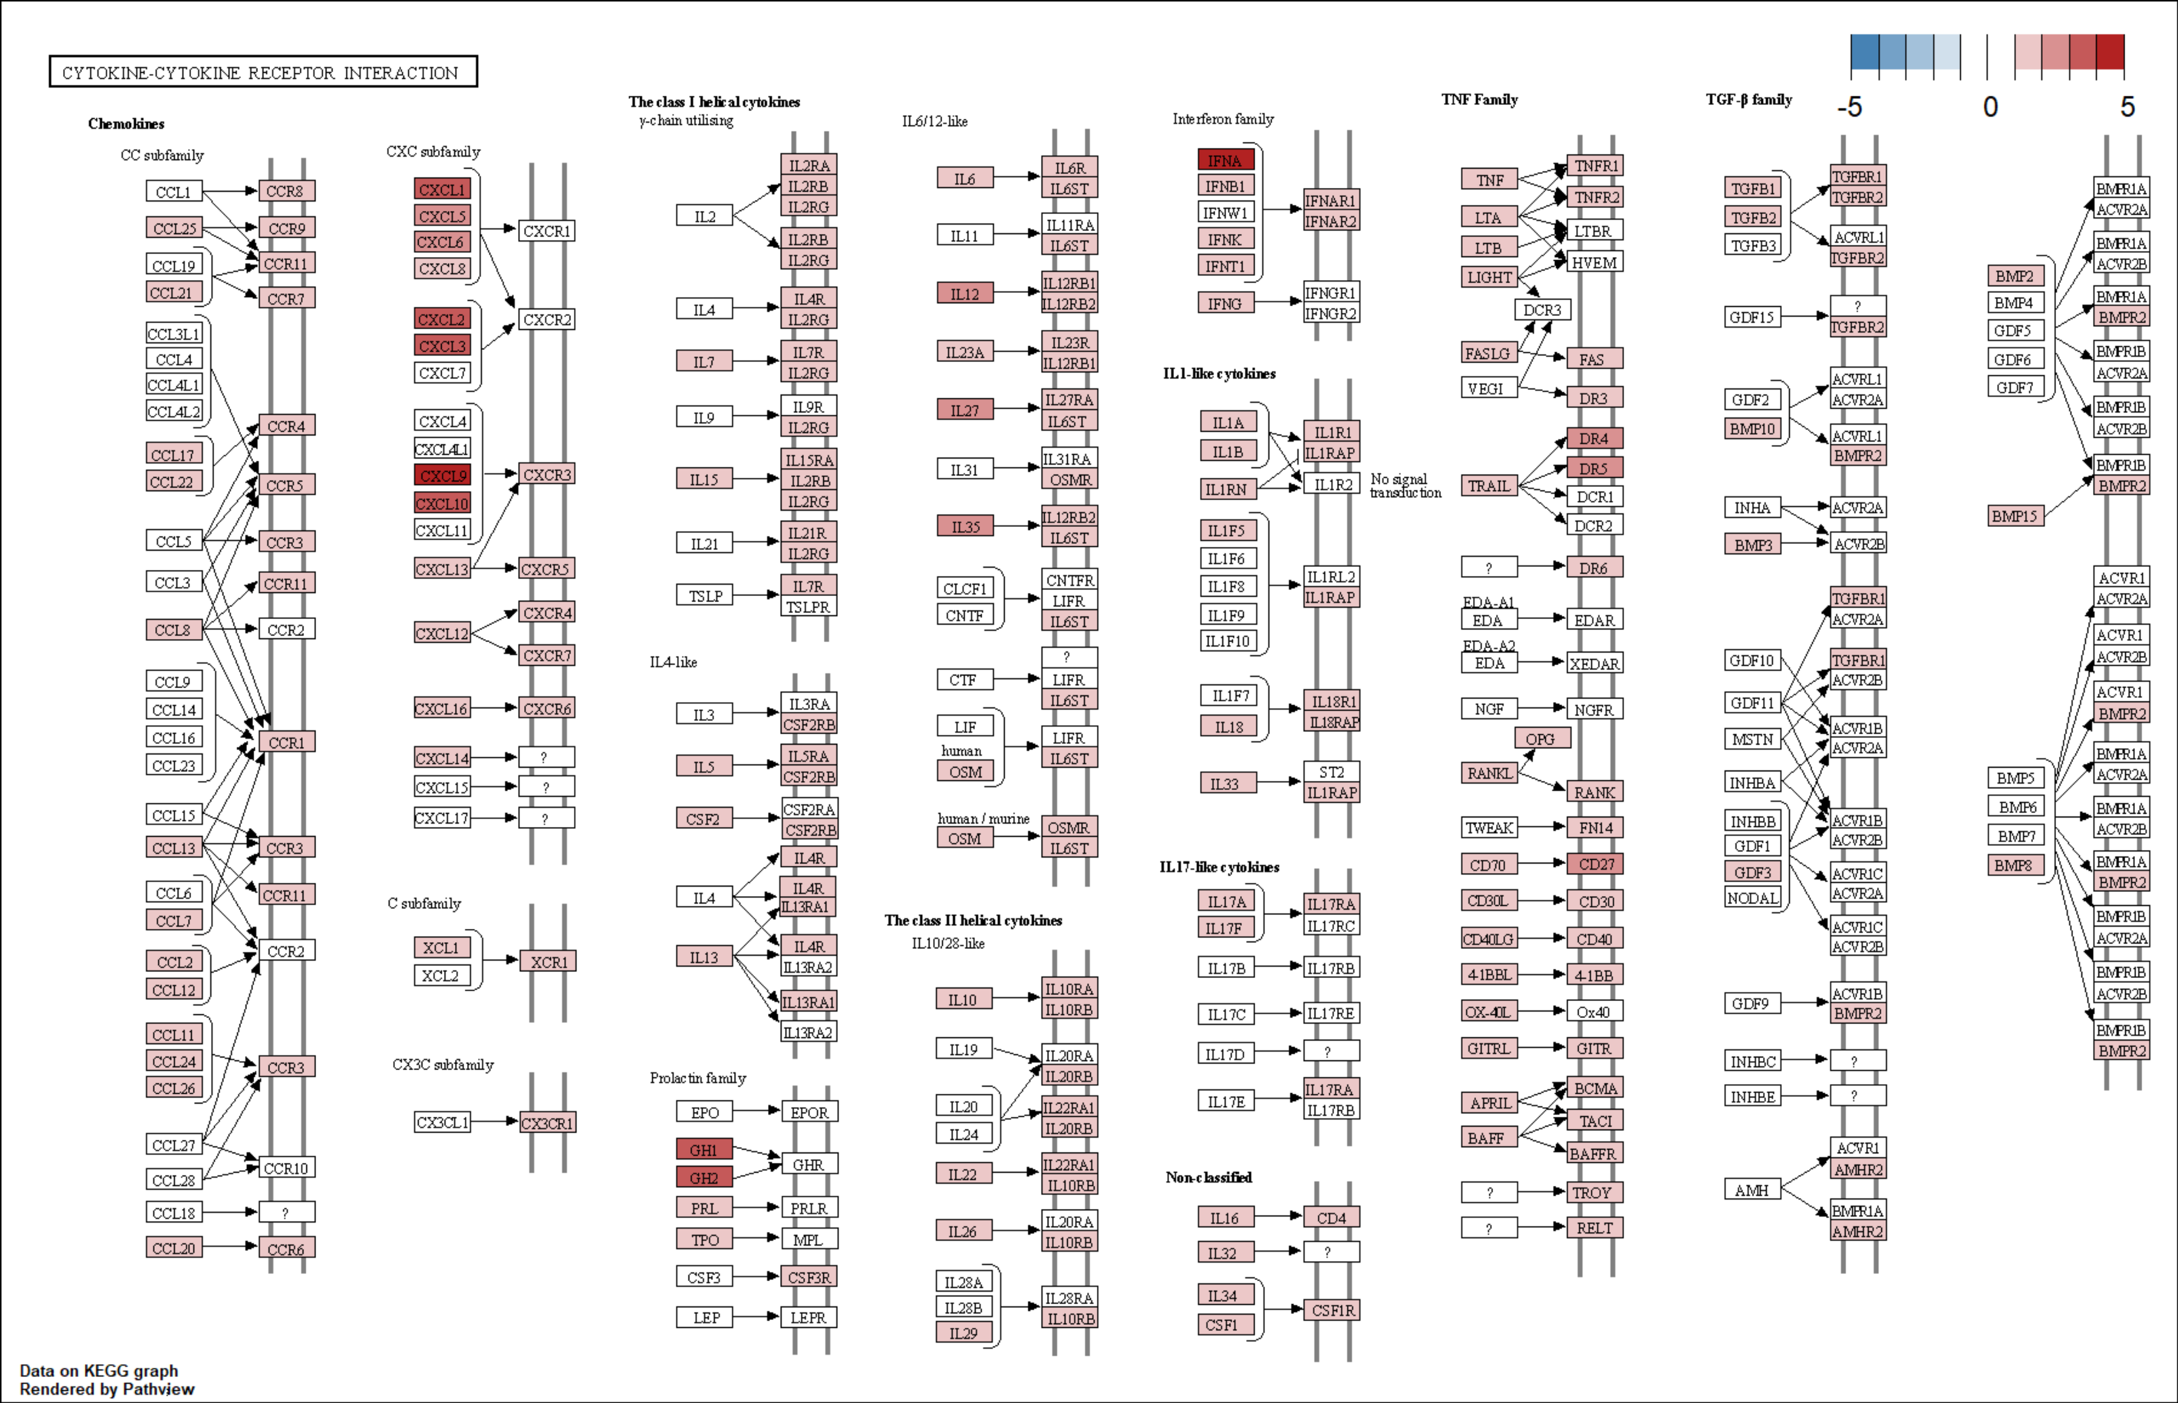

**Supplementary Figure S12. Pathview diagram of modulation of the KEGG cytokine-cytokine receptor interaction pathway for CXCL9high RCC.** *Regulation of particular components of the KEGG cytokine-cytokine receptor interaction pathway (HSA 4060) based on differential gene expression in CXCL9high versus CXCL9low cancers was visualized with the Pathview tool. Color labeling of the pathway components corresponds to the fold-regulation estimate versus CXCL9low tumors.*

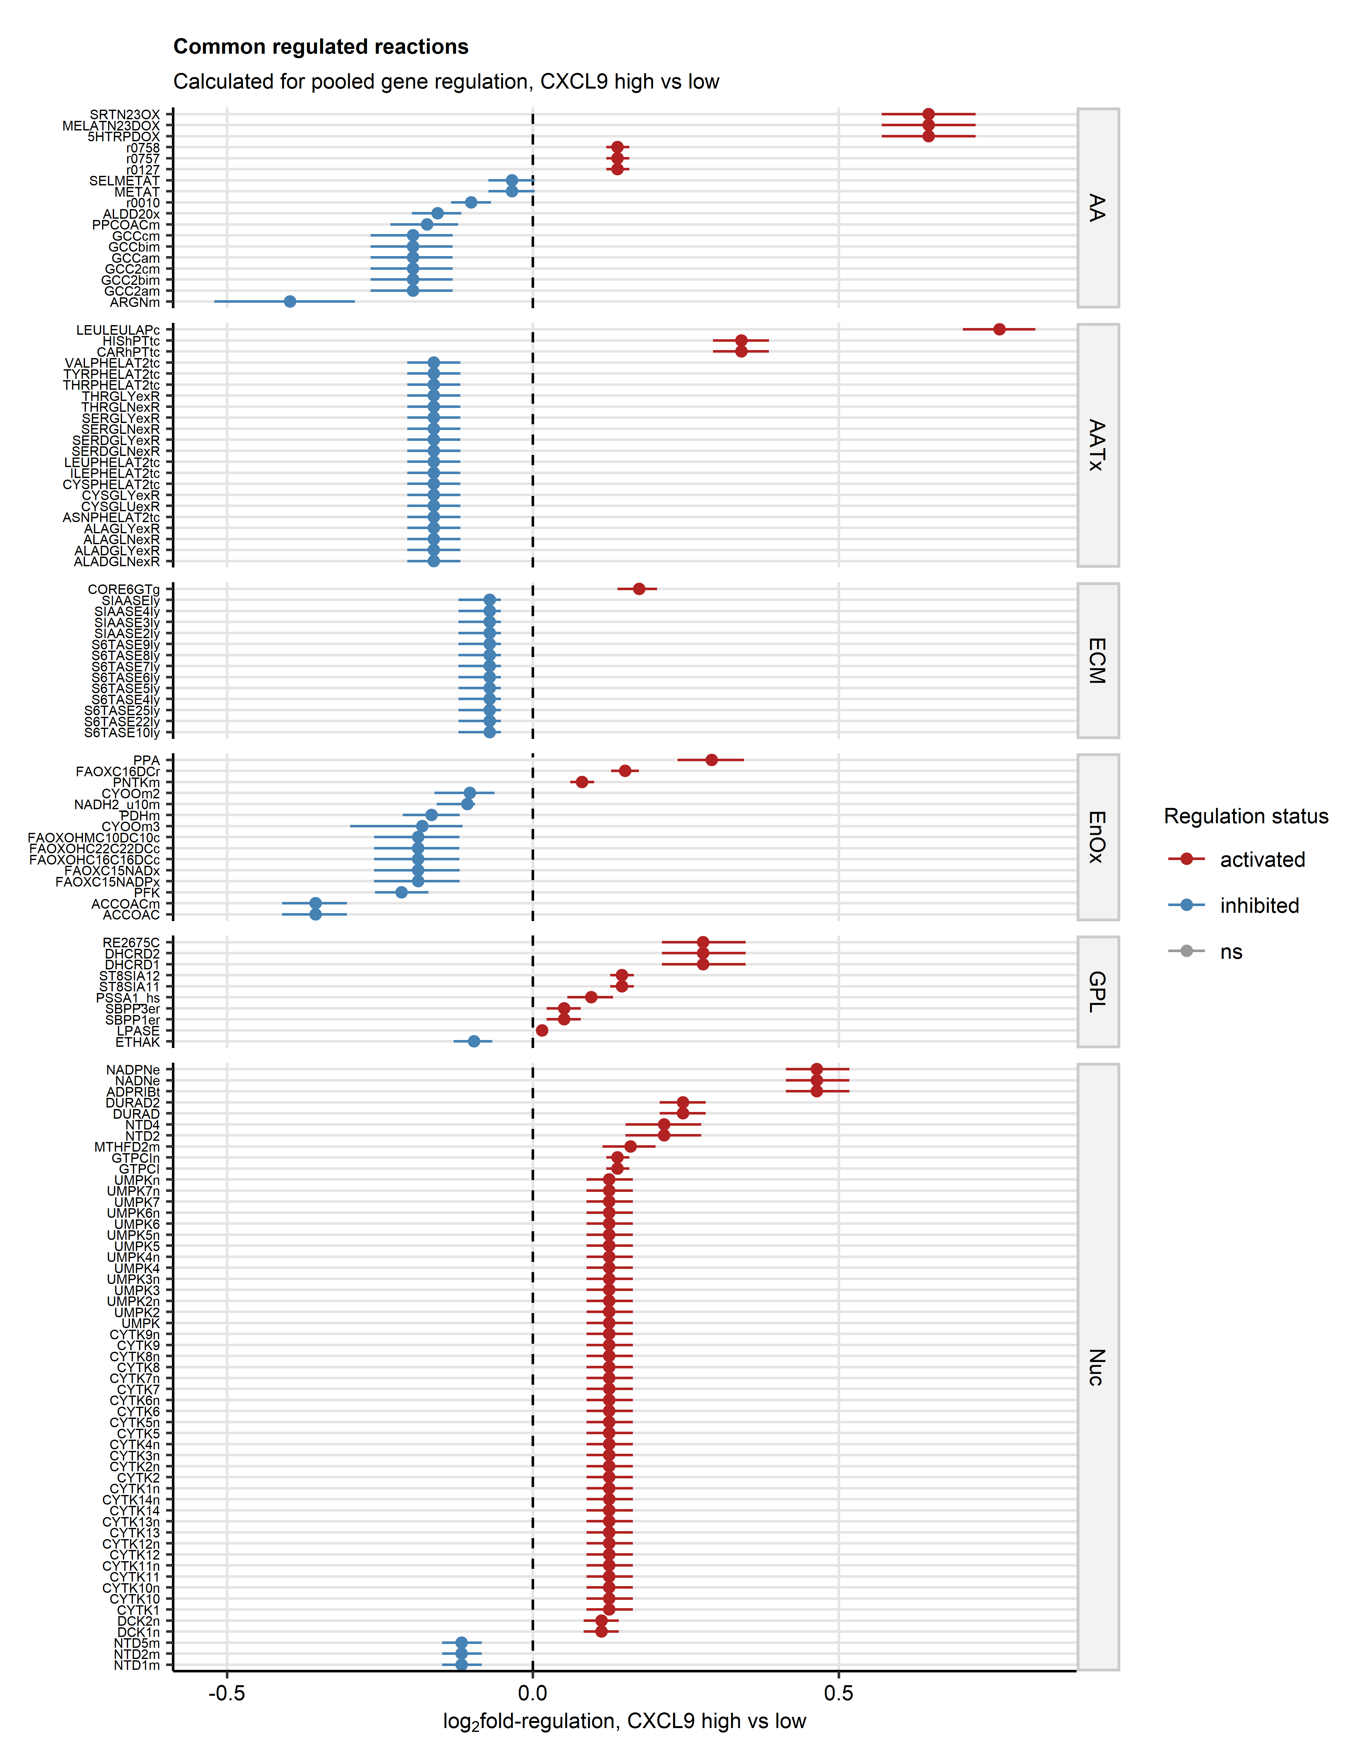

**Supplementary Figure S13. Prediction of metabolic reactions modulation based on pooled estimates of differential gene expression in CXCL9high tumors.** *Regulation of metabolic reactions in CXCL9high versus CXCL9low cancer based on pooled estimates of differential gene expression was predicted with the BiGGR and biggrExtra tools. Fold-regulation estimates for reactions associated with aminoacid metabolism (AA), aminoacid transport (AATx), extracellular matrix protein turnover (ECM), oxidative energy metabolism (EnOx), glycophospholipid (GPL) and nucleotide metabolism (Nuc) found regulated in at least 6 out of 8 investigated cohorts are presented in a Forest plot. Points with whiskers represent fold-regulation estimates with 95% confidence intervals. Point color codes for significance and regulation sign. Reactions are labeled with their BiGG database identifiers.*

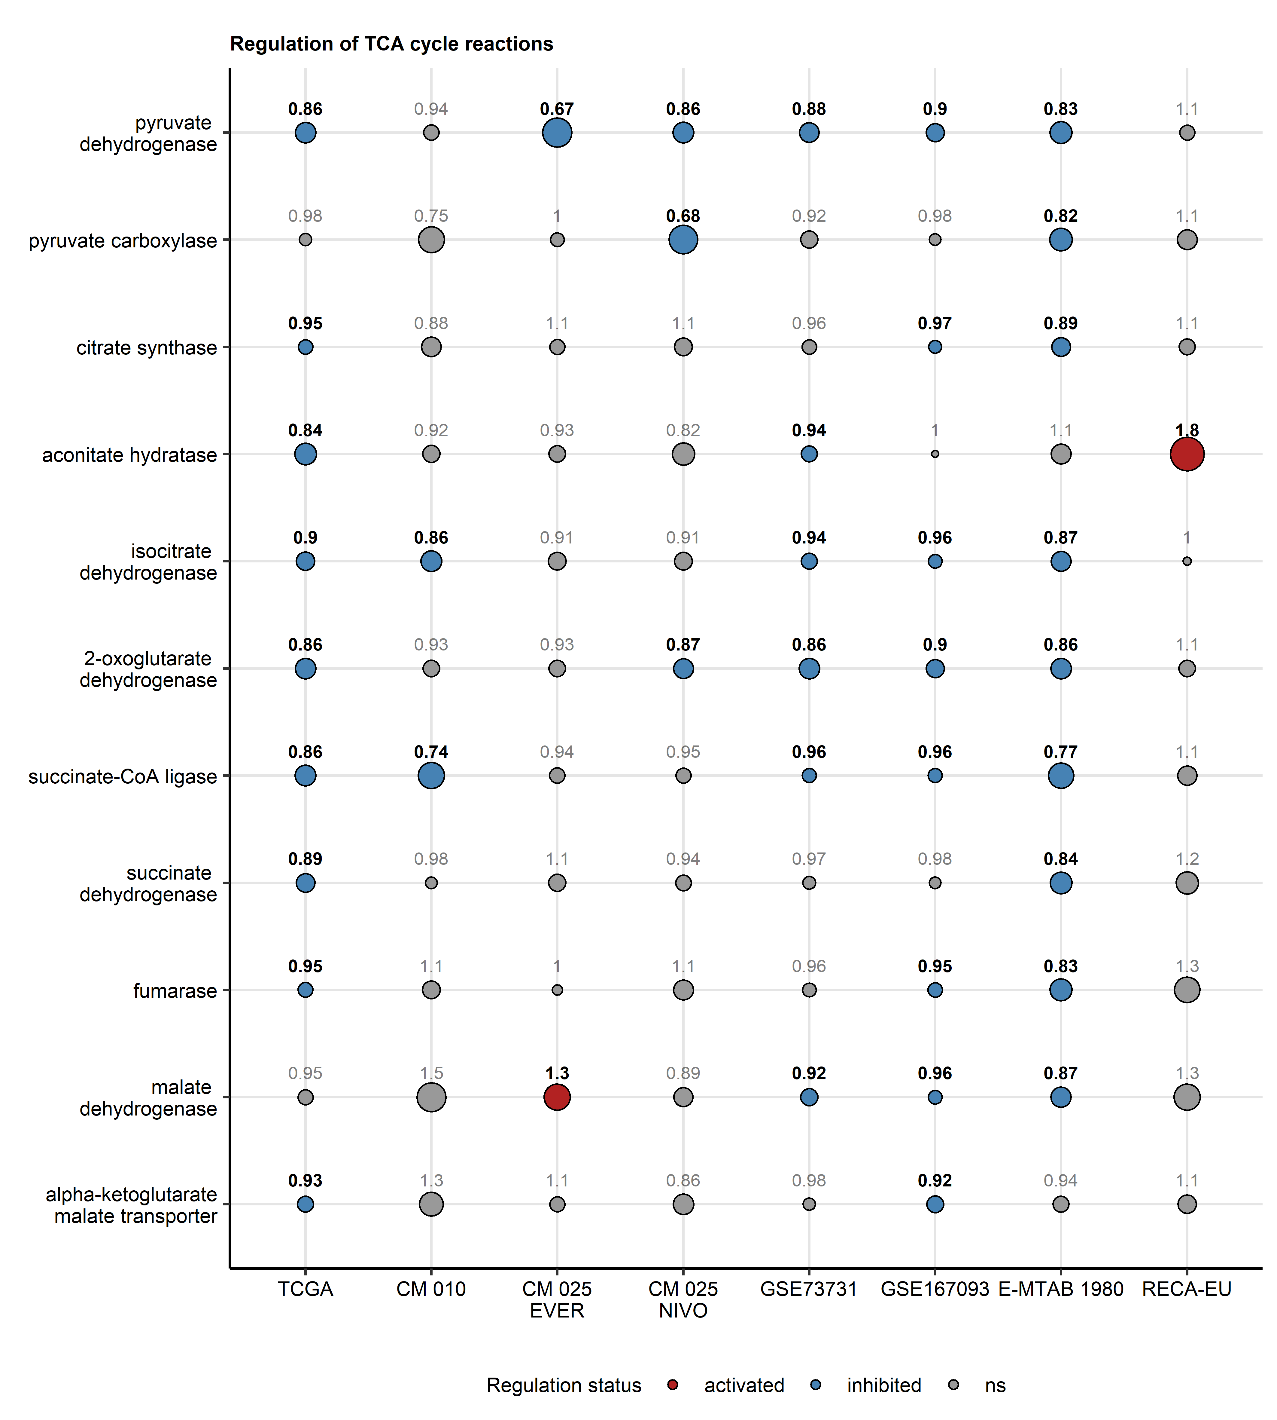

**Supplementary Figure S14. Predicted regulation of TCA reactions in CXCL9high tumors.** *Regulation of metabolic reactions in CXCL9high versus CXCL9low cancer based on estimates of differential gene expression was predicted with the BiGGR and biggrExtra tools. Fold-regulation estimates for the TCA (tri-carboxylic acid) cycle reactions are presented in a bubble plot. Point size corresponds to the absolute value of log2 fold-regulation estimate. Point color codes for significance and regulation sign. Points are labeled with the fold-regulation estimate value. Values for significant reactions are highlighted in bold. CM: CheckMate, EVER: everolimus, NIVO: nivolumab.*

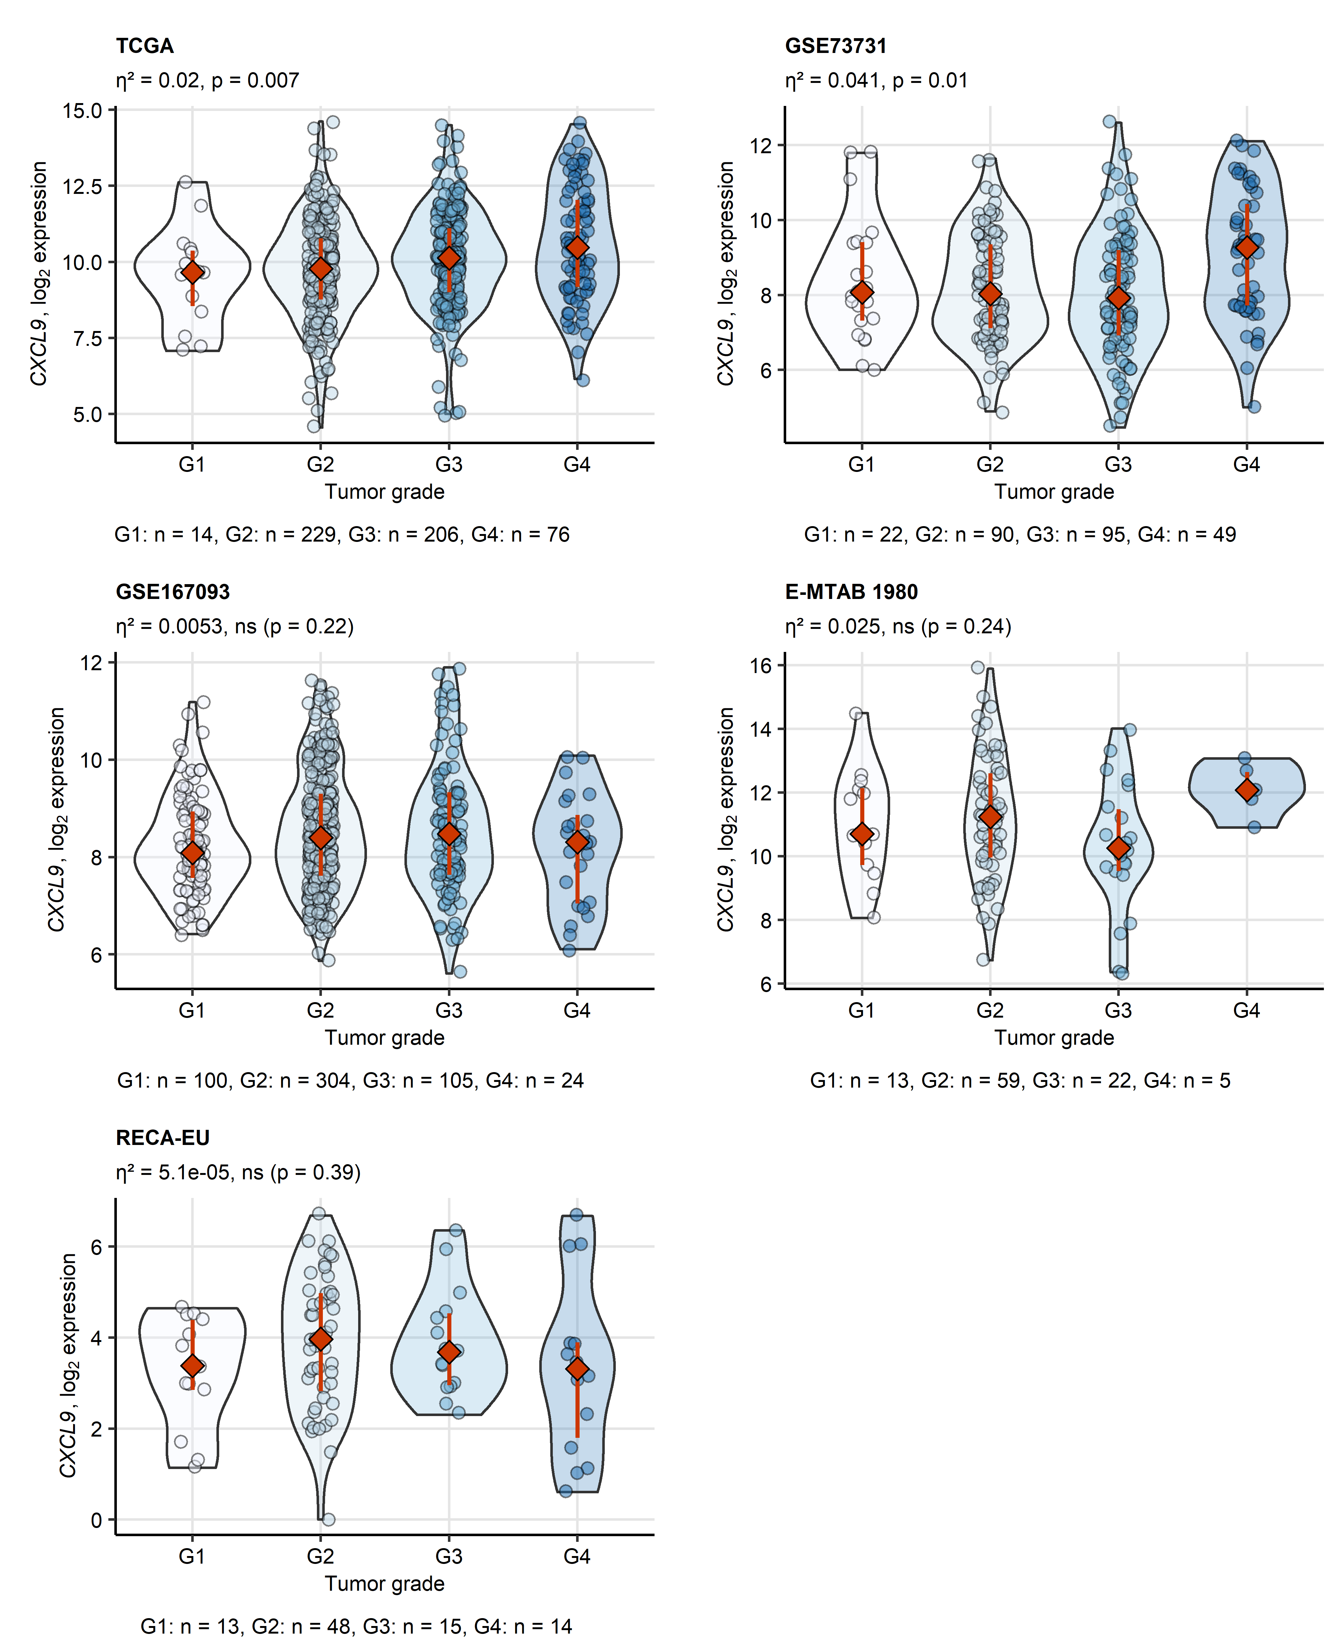

**Supplementary Figure S15. Tumor grade and CXCL9 expression.** *log2-transformed CXCL9 expression levels in the RCC tissue in the TCGA, GSE73731, GSE167093, E-MTAB 1980 and EU RECA cohorts were compared between tumor grades by Kruskal-Wallis test corrected for multiple testing with $η^{2}$ effect size statistic. P values were corrected for multiple testing with Benjamini-Hochberg method. Expression values are presented in violin plots. Points represent cancer samples. Red diamonds with whiskers depict median values with interquartile ranges. Effect size statistic and p values are displayed in the plot captions. Numbers of complete observations per tumor grade are indicated under the plots.*

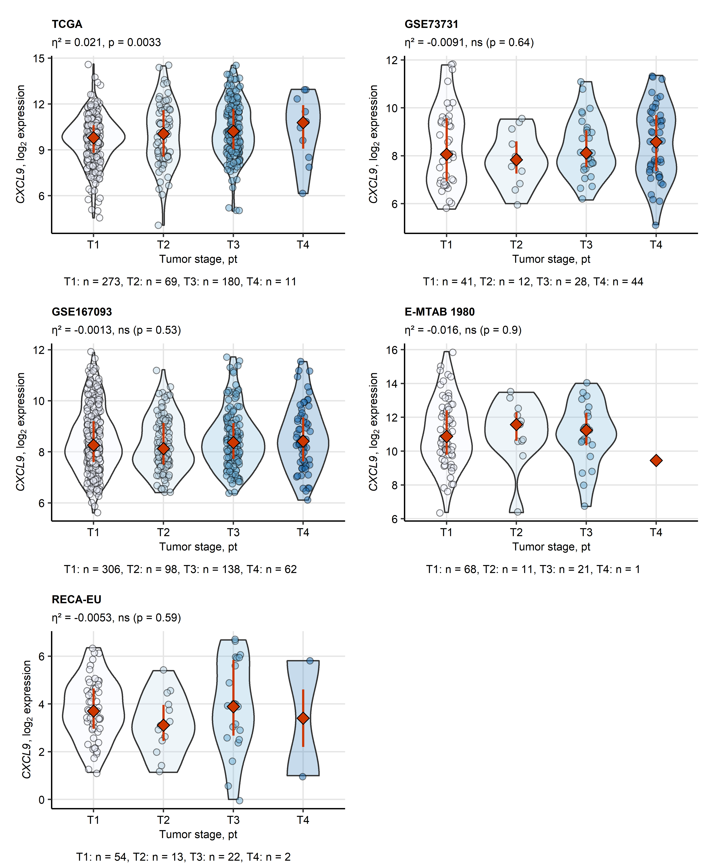

**Supplementary Figure S16. Tumor stage and CXCL9 expression.** *log2-transformed CXCL9 expression levels in the RCC tissue in the TCGA, GSE73731, GSE167093, E-MTAB 1980 and EU RECA cohorts were compared between tumor stages by Kruskal-Wallis test corrected for multiple testing with $η^{2}$ effect size statistic. P values were corrected for multiple testing with Benjamini-Hochberg method. Expression values are presented in violin plots. Points represent cancer samples. Red diamonds with whiskers depict median values with interquartile ranges. Effect size statistic and p values are displayed in the plot captions. Numbers of complete observations per tumor stage are indicated under the plots.*

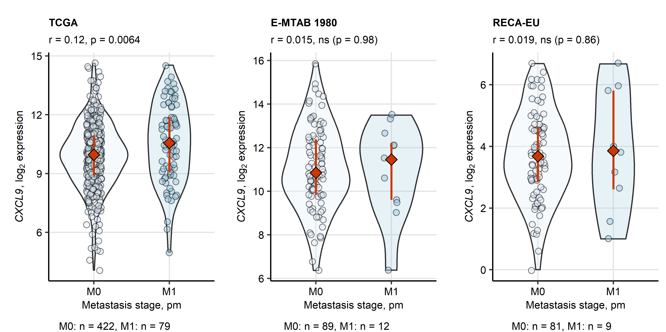

**Supplementary Figure S17. Distant metastases at RCC diagnosis and CXCL9 expression.** *log2-transformed CXCL9 expression levels in the RCC tissue in the TCGA, E-MTAB 1980 and EU RECA cohorts were compared between patients with (M1) and without distant metastases (M0) at RCC diagnosis by Mann-Whitney test with r effect size statistic. P values were corrected for multiple testing with Benjamini-Hochberg method. Expression values are presented in violin plots. Points represent cancer samples. Red diamonds with whiskers depict median values with interquartile ranges. Effect size statistic and p values are displayed in the plot captions. Numbers of complete observations are indicated under the plots.*

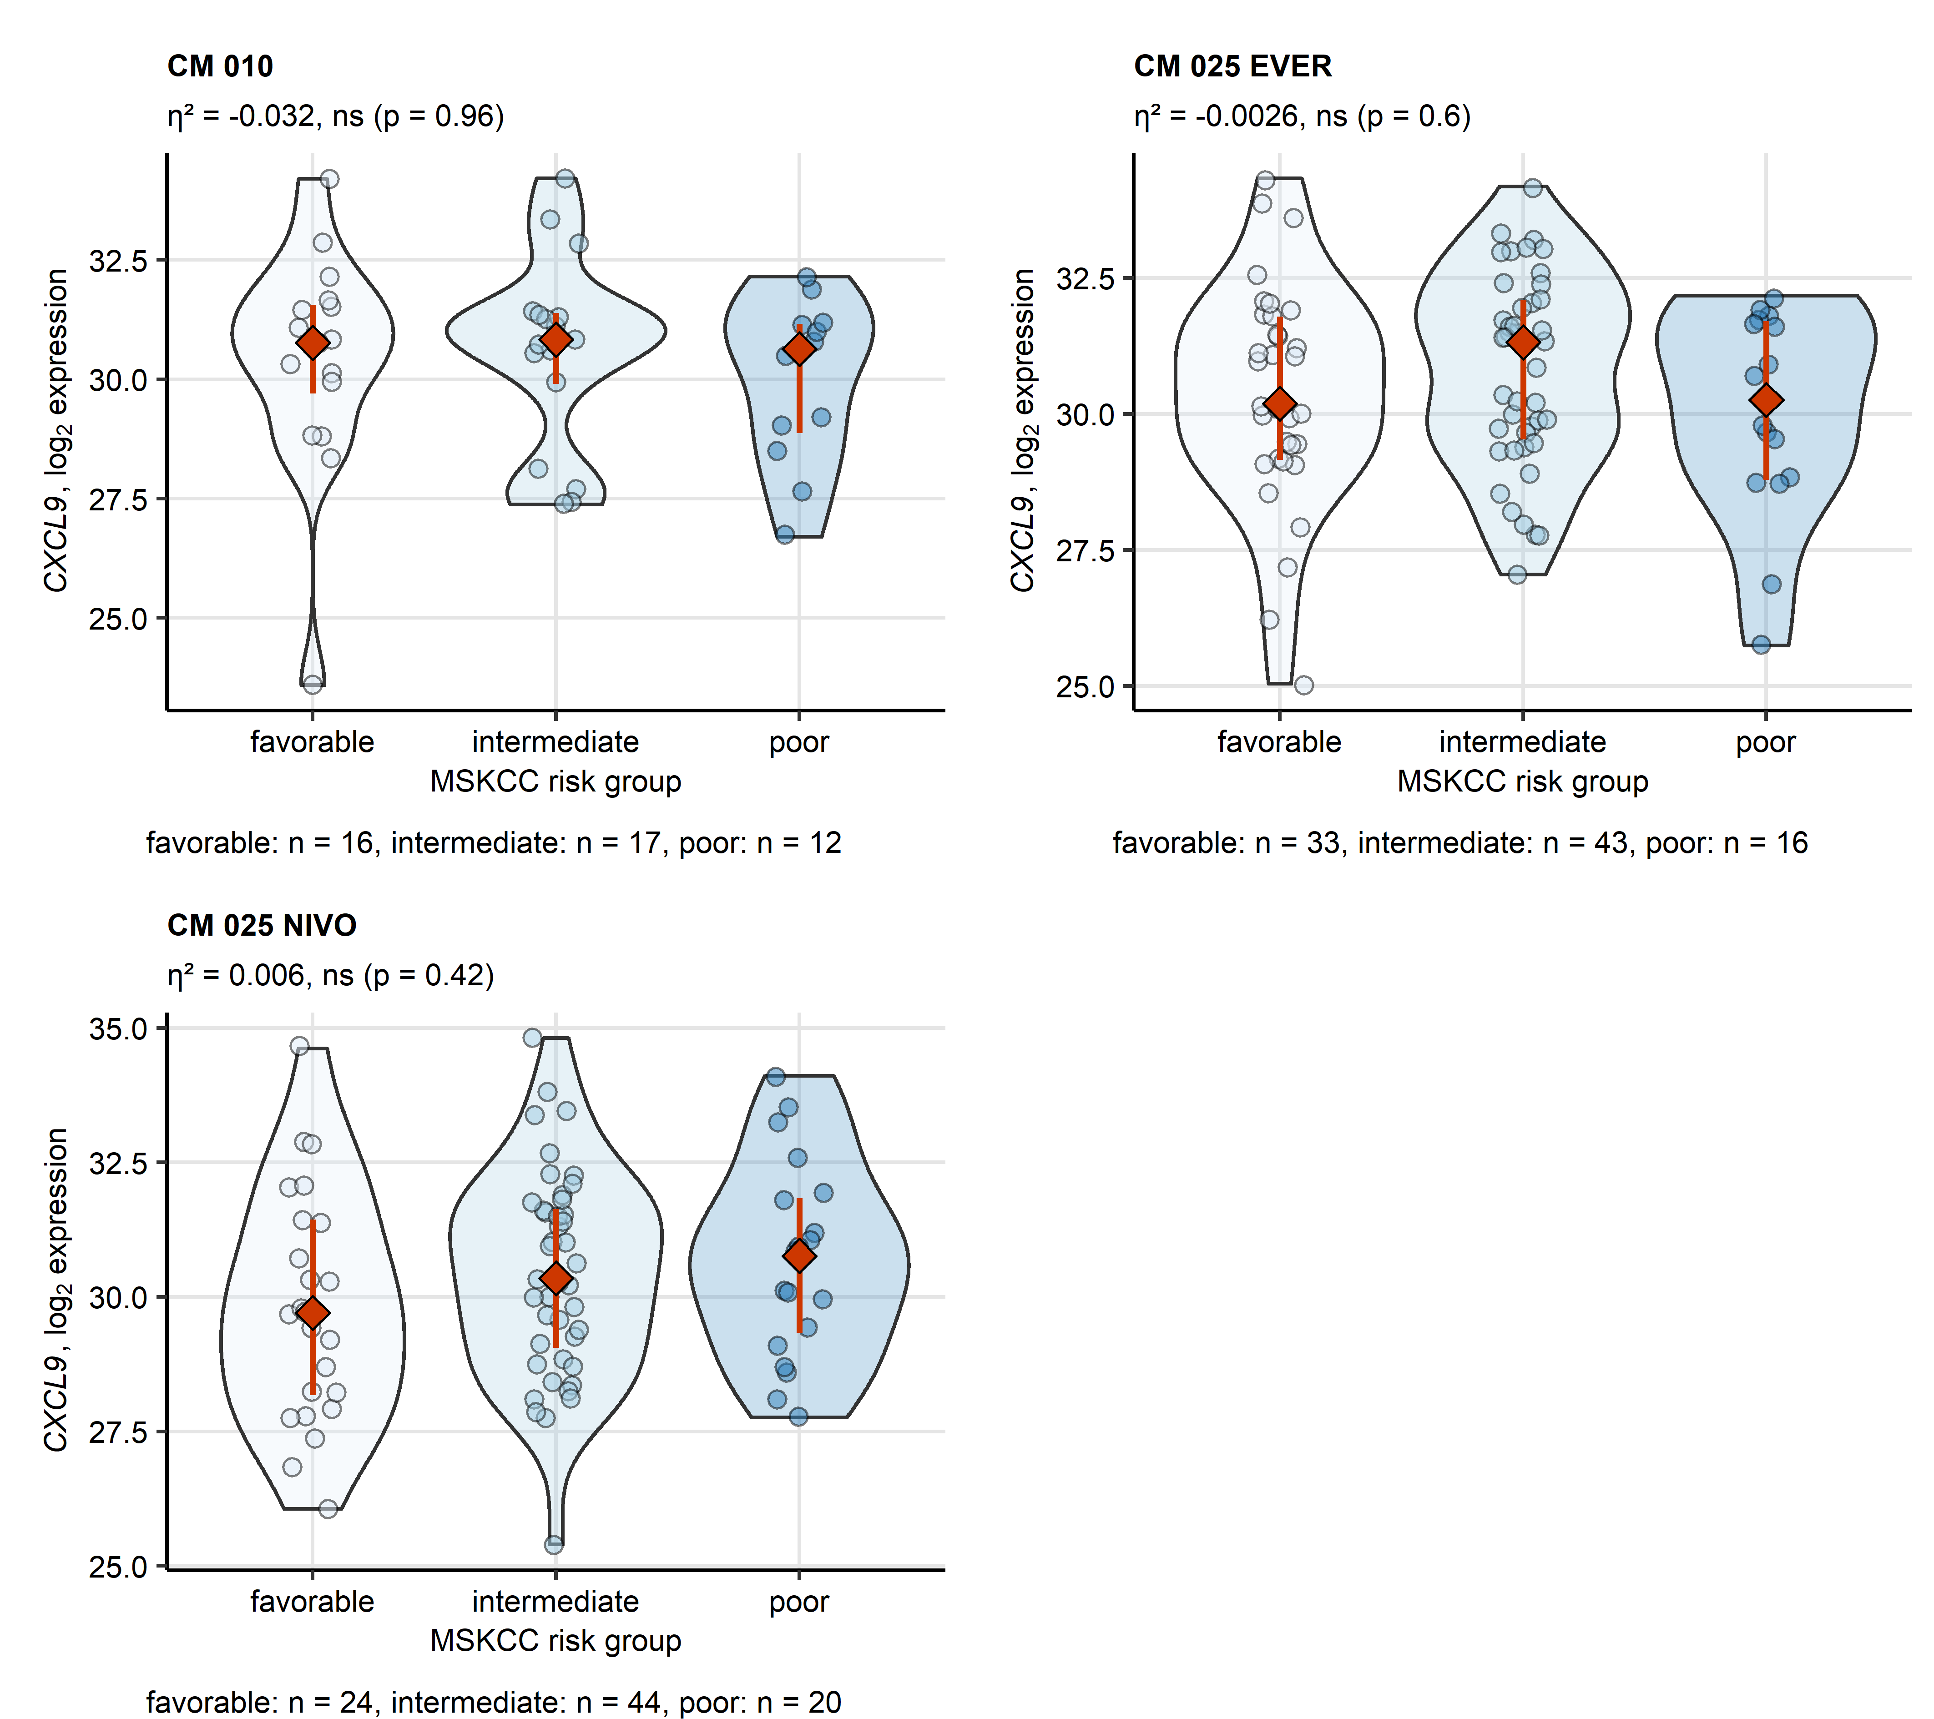

**Supplementary Figure S18. MSKCC risk classification and CXCL9 expression.** *log2-transformed CXCL9 expression levels in the RCC tissue in the CheckMate 010 (CM 010), CheckMate 025 everolimus (CM 025 EVER) and CheckMate 025 nivolumab (CM 025 NIVO) cohorts were compared between patients with favorable, intermediate and poor MSKCC risk prognosis by Kruskal-Wallis test with $η^{2}$ effect size statistic. P values were corrected for multiple testing with Benjamini-Hochberg method. Expression values are presented in violin plots. Points represent cancer samples. Red diamonds with whiskers depict median values with interquartile ranges. Effect size statistic and p values are displayed in the plot captions. Numbers of complete observations per risk group are indicated under the plots.*

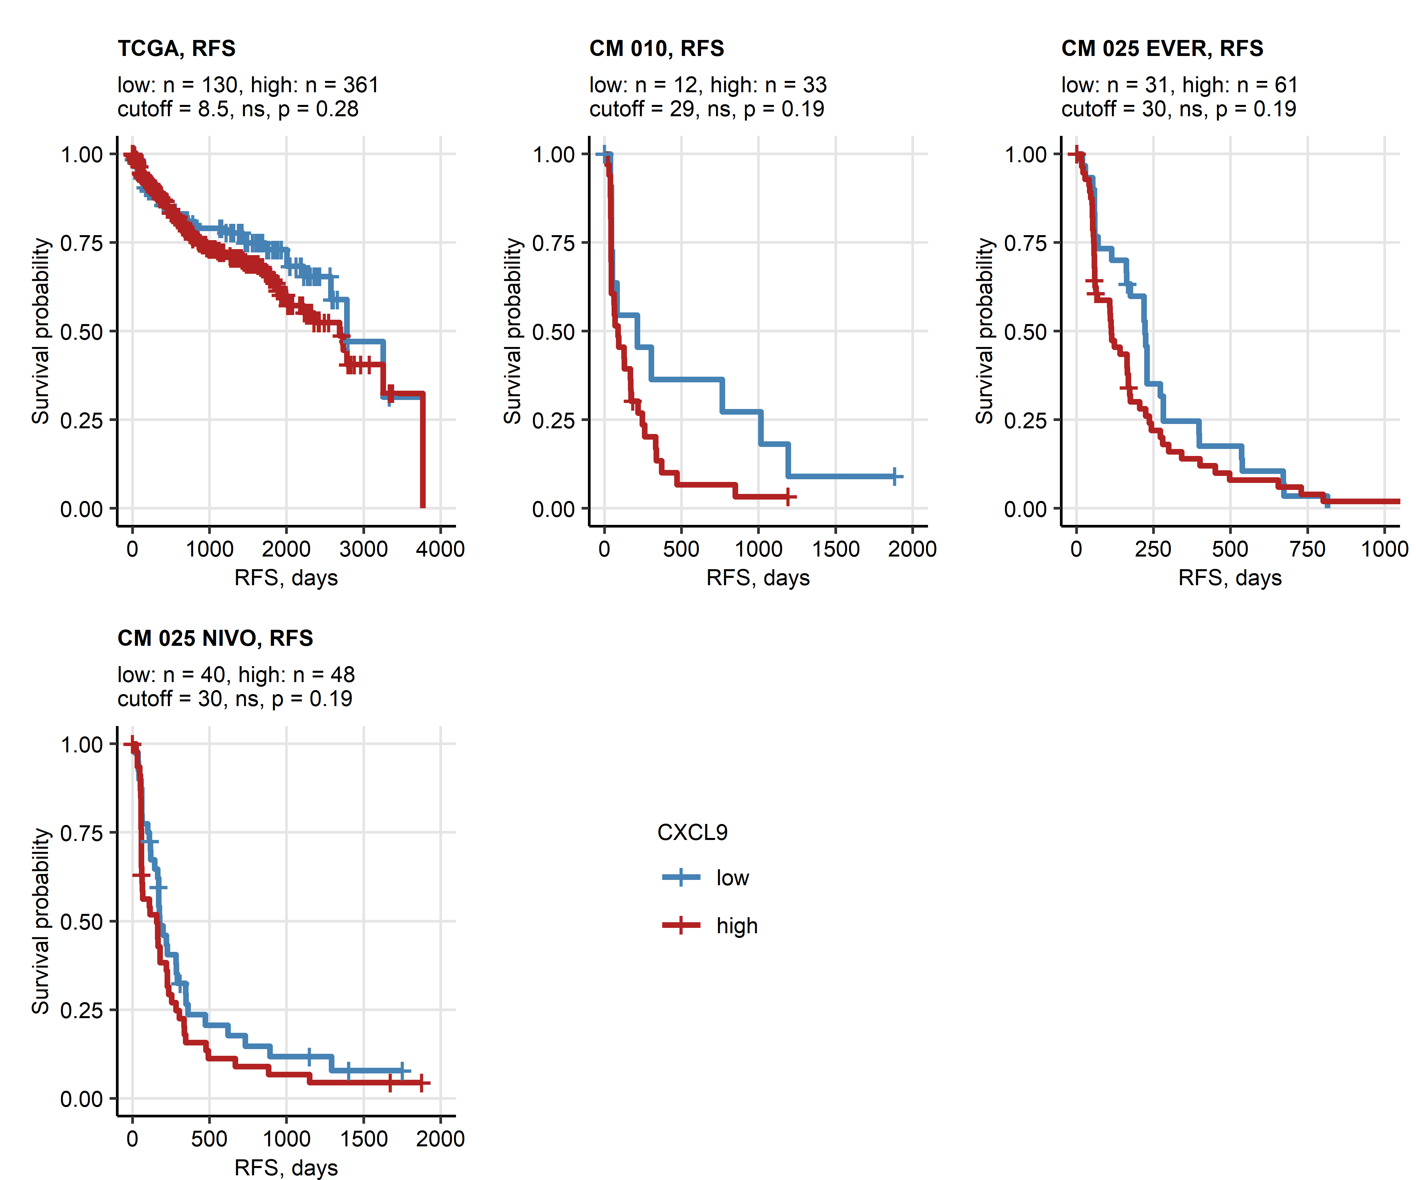

**Supplementary Figure S19. Relapse-free survival of patients bearing CXCL9high and CXCL9low RCC.** *Cancer samples in the TCGA, CheckMate 010 (CM 010), CheckMate 025 everolimus (CM 025 EVER) and CheckMate 025 nivolumab (CM025 NIVO) collectives were classified as CXCL9low and CXCL9high with the cutoffs corresponding to the largest differences in relapse-free survival (RFS). Differences in RFS between the CXCL9 expression strata were investigated with Mentel-Henszel test corrected for multiple testing with Benjamini-Hochberg method. Fractions of surviving patients are presented in Kaplan-Meier plots. Numbers of low and high expressors, cutoff and p values are displayed in the plot captions.*

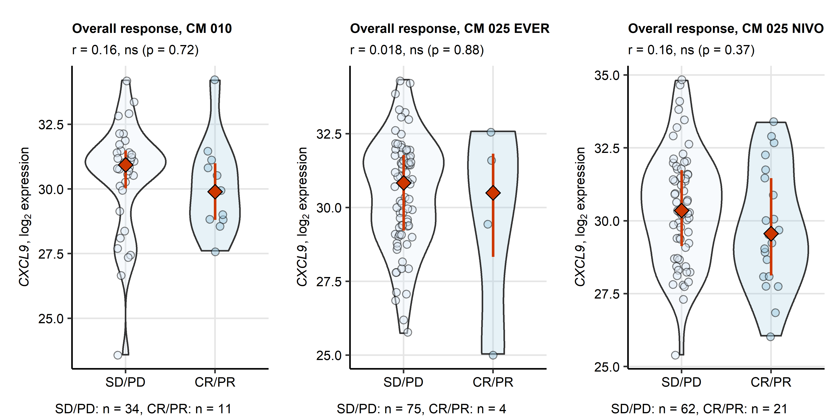

**Supplementary Figure S20. Expression of CXCL9 in patients with and without clinical response to everolimus and nivolumab therapy.** *log2-transformed CXCL9 expression levels in the RCC tissue in the CheckMate 010 (CM 010), CheckMate 025 everolimus (CM 025 EVER) and CheckMate 025 nivolumab (CM 025 NIVO) were compared between patients with and without overall therapy response (response: complete [CR] or partial response [PR], no response: stable [SD] or progressive disease [PD]) by Mann-Whitney test with r effect size statistic. P values were corrected for multiple testing with Benjamini-Hochberg method. Expression values are presented in violin plots. Points represent cancer samples. Red diamonds with whiskers depict median values with interquartile ranges. Effect size statistic and p values are displayed in the plot captions. Numbers of complete observations are indicated under the plots.*

# References

1. Creighton CJ, Morgan M, Gunaratne PH, Wheeler DA, Gibbs RA, Robertson G, Chu A, Beroukhim R, Cibulskis K, Signoretti S, et al. Comprehensive molecular characterization of clear cell renal cell carcinoma. *Nature 2013 499:7456* (2013) 499:43–49. doi: [10.1038/nature12222](https://doi.org/10.1038/nature12222)

2. Braun DA, Hou Y, Bakouny Z, Ficial M, Sant’ Angelo M, Forman J, Ross-Macdonald P, Berger AC, Jegede OA, Elagina L, et al. Interplay of somatic alterations and immune infiltration modulates response to PD-1 blockade in advanced clear cell renal cell carcinoma. *Nature medicine* (2020) 26:909. doi: [10.1038/S41591-020-0839-Y](https://doi.org/10.1038/S41591-020-0839-Y)

3. RECA. RECA-EU, ICGC Data Portal. <https://dcc.icgc.org/projects/RECA-EU> [Accessed August 16, 2022]

4. Wei X, Choudhury Y, Lim WK, Anema J, Kahnoski RJ, Lane B, Ludlow J, Takahashi M, Kanayama HO, Belldegrun A, et al. Recognizing the Continuous Nature of Expression Heterogeneity and Clinical Outcomes in Clear Cell Renal Cell Carcinoma. *Scientific reports* (2017) 7: doi: [10.1038/S41598-017-07191-Y](https://doi.org/10.1038/S41598-017-07191-Y)

5. Laskar RS, Li P, Ecsedi S, Abedi-Ardekani B, Durand G, Robinot N, Hubert JN, Janout V, Zaridze D, Mukeria A, et al. Sexual dimorphism in cancer: insights from transcriptional signatures in kidney tissue and renal cell carcinoma. *Human molecular genetics* (2021) 30:343–355. doi: [10.1093/HMG/DDAB031](https://doi.org/10.1093/HMG/DDAB031)

6. Sean D, Meltzer PS. GEOquery: a bridge between the Gene Expression Omnibus (GEO) and BioConductor. *Bioinformatics (Oxford, England)* (2007) 23:1846–1847. doi: [10.1093/BIOINFORMATICS/BTM254](https://doi.org/10.1093/BIOINFORMATICS/BTM254)

7. Sato Y, Yoshizato T, Shiraishi Y, Maekawa S, Okuno Y, Kamura T, Shimamura T, Sato-Otsubo A, Nagae G, Suzuki H, et al. Integrated molecular analysis of clear-cell renal cell carcinoma. *Nature Genetics 2013 45:8* (2013) 45:860–867. doi: [10.1038/ng.2699](https://doi.org/10.1038/ng.2699)

8. Finotello F, Mayer C, Plattner C, Laschober G, Rieder Di, Hackl H, Krogsdam A, Loncova Z, Posch W, Wilflingseder D, et al. Molecular and pharmacological modulators of the tumor immune contexture revealed by deconvolution of RNA-seq data. *Genome Medicine* (2019) 11:34. doi: [10.1186/s13073-019-0638-6](https://doi.org/10.1186/s13073-019-0638-6)

9. Sturm G, Finotello F, List M. Immunedeconv: An R Package for Unified Access to Computational Methods for Estimating Immune Cell Fractions from Bulk RNA-Sequencing Data. *Methods in molecular biology (Clifton, NJ)* (2020) 2120:223–232. doi: [10.1007/978-1-0716-0327-7_16](https://doi.org/10.1007/978-1-0716-0327-7_16)

10. Wickham H, Averick M, Bryan J, Chang W, McGowan L, François R, Grolemund G, Hayes A, Henry L, Hester J, et al. Welcome to the Tidyverse. *Journal of Open Source Software* (2019) 4:1686. doi: [10.21105/joss.01686](https://doi.org/10.21105/joss.01686)

11. Wickham Hadley. *ggplot2: Elegant Graphics for Data Analysis*. 1st ed. New York: Springer-Verlag (2016). [https://ggplot2.tidyverse.org](https://ggplot2.tidyverse.org/)

12. Wilke CO. *Fundamentals of Data Visualization: A Primer on Making Informative and Compelling Figures*. 1st ed. Sebastopol: O’Reilly Media (2019).

13. Kassambara A, Kosinski M, Biecek P. survminer: Drawing Survival Curves using ’ggplot2’. (2016) <https://cran.r-project.org/package=survminer>

14. Benjamini Y, Hochberg Y. Controlling the False Discovery Rate: A Practical and Powerful Approach to Multiple Testing. *Journal of the Royal Statistical Society: Series B (Methodological)* (1995) 57:289–300. doi: [10.1111/j.2517-6161.1995.tb02031.x](https://doi.org/10.1111/j.2517-6161.1995.tb02031.x)

15. Kassambara A. rstatix: Pipe-Friendly Framework for Basic Statistical Tests. (2021) <https://cran.r-project.org/package=rstatix>

16. Therneau TM, Grambsch PM. *Modeling Survival Data: Extending the Cox Model*. 1st ed. New York: Springer Verlag (2000).

17. Kocher F, Tymoszuk P, Amann A, Sprung S, Salcher S, Daum S, Haybaeck J, Rinnerthaler G, Huemer F, Kauffmann-Guerrero D, et al. Deregulated glutamate to pro-collagen conversion is associated with adverse outcome in lung cancer and may be targeted by renin-angiotensin-aldosterone system (RAS) inhibition. *Lung Cancer* (2021) 159:84–95. doi: [10.1016/j.lungcan.2021.06.020](https://doi.org/10.1016/j.lungcan.2021.06.020)

18. Eigentler A, Tymoszuk P, Zwick J, Schmitz AA, Pircher A, Kocher F, Schlicker A, Lesche R, Schäfer G, Theurl I, et al. The Impact of Cand1 in Prostate Cancer. *Cancers* (2020) 12: doi: [10.3390/cancers12020428](https://doi.org/10.3390/cancers12020428)

19. Young MD, Wakefield MJ, Smyth GK, Oshlack A. Gene ontology analysis for RNA-seq: accounting for selection bias. *Genome Biology* (2010) 11:R14. doi: [10.1186/gb-2010-11-2-r14](https://doi.org/10.1186/gb-2010-11-2-r14)

20. Tarca AL, Draghici S, Khatri P, Hassan SS, Mittal P, Kim JS, Kim CJ, Kusanovic JP, Romero R. A novel signaling pathway impact analysis. *Bioinformatics* (2009) 25:75–82. doi: [10.1093/bioinformatics/btn577](https://doi.org/10.1093/bioinformatics/btn577)

21. Balduzzi S, Rücker G, Schwarzer G. How to perform a meta-analysis with R: A practical tutorial. *Evidence-Based Mental Health* (2019) 22:153–160. doi: [10.1136/ebmental-2019-300117](https://doi.org/10.1136/ebmental-2019-300117)

22. Luo W, Brouwer C. Pathview: An R/Bioconductor package for pathway-based data integration and visualization. *Bioinformatics* (2013) 29:1830–1831. doi: [10.1093/bioinformatics/btt285](https://doi.org/10.1093/bioinformatics/btt285)

23. Hänzelmann S, Castelo R, Guinney J. GSVA: Gene set variation analysis for microarray and RNA-Seq data. *BMC Bioinformatics* (2013) 14:7. doi: [10.1186/1471-2105-14-7](https://doi.org/10.1186/1471-2105-14-7)

24. King ZA, Lu J, Dräger A, Miller P, Federowicz S, Lerman JA, Ebrahim A, Palsson BO, Lewis NE. BiGG Models: A platform for integrating, standardizing and sharing genome-scale models. *Nucleic Acids Research* (2016) 44:D515–D522. doi: [10.1093/NAR/GKV1049](https://doi.org/10.1093/NAR/GKV1049)

25. Gavai AK, Supandi F, Hettling H, Murrell P, Leunissen JAM, Van Beek JHGM. Using Bioconductor Package BiGGR for Metabolic Flux Estimation Based on Gene Expression Changes in Brain. *PLOS ONE* (2015) 10:e0119016. doi: [10.1371/JOURNAL.PONE.0119016](https://doi.org/10.1371/JOURNAL.PONE.0119016)